Telusko: Advance Java 01

SQL / JDBC

081 SQL 1

Q>
class Counter implements Runnable {
private static int i = 3;
@Override
public void run() {
System.out.print(i--);
}
}
public class Test {
public static void main(String[] args) {
Thread t1 = new Thread(new Counter());
Thread t2 = new Thread(new Counter());
Thread t3 = new Thread(new Counter());
Thread[] threads = {t1, t2, t3};
for(Thread thread : threads) {
thread.start();
}
}
}
What will be the result of compiling and executing Test class?
A. Always print 321
B. prints 321 but order can be different
C. It always print 210
D. It always print 210 but order can be different
E. None of the other options
Answer: B
2.
Which method must be defined by a class implementing the java.lang.Runnable
interface?
1. void run()
2. public void run()
3. public void start()
4. None of these.
Answer: 2
3.
Which of the following are the valid constructors of Thread class?
i. Thread(Runnable r, String name)
ii. Thread()
iii. Thread(int priority)
iv. Thread(Runnable r, ThreadGroup g)
v. Thread(Runnable r, int priority)
Option
1. ii and iv
2. ii and v
3. i and iii
4. i and ii
5. None
Answer: 4
4.What will be the output of the following Java code snippet?
class ThreadDemo extends Thread {
final StringBuffer sb1 = new StringBuffer();
final StringBuffer sb2 = new StringBuffer();
public static void main(String args[]) {
final ThreadDemo h = new ThreadDemo();
new Thread() {
public void run() {
synchronized(this) {
h.sb1.append("Java");
h.sb2.append("Thread");
System.out.println(h.sb1);
System.out.println(h.sb2);
}
}
}.start();
new Thread() {
public void run(){
synchronized(this) {
h.sb1.append("Mutithreading”);
h.sb2.append("Example");
System.out.println(h.sb2);
System.out.println(h.sb1);
}
}
}.start();
}
}
Choose the option
1. Multithreading Example java Thread.
2. None of these.
3. Java Thread Multithreading Example.
4. The order in which text will be printed cannot be determined.
5. Java Thread ThreadExample JavaMultithreading.
Answer : 5
5.
What will be the output of the below Java program?
class MyThread extends Thread {
MyThread() {}
MyThread(Runnable r) {super(r); }
public void run() {
System.out.print("Inside Thread ");
}
}
class RunnableDemo implements Runnable {
@Override
public void run() {
System.out.print(" Inside Runnable");
}
}
class ThreadDemo {
public static void main(String[] args) {
new MyThread().start();
new MyThread(new RunnableDemo()).start();}
}
1. None of these.
2. Prints "Inside Thread Inside Runnable".
3. Does not compile.
4. Prints "Inside Thread Inside Thread".
5. Throws exception at runtime.
Answer: 4

INSERT INTO studentinfo VALUES(1, 'hyder', 'abbas','najafi', 28, 'Bengaluru');

INSERT INTO studentinfo VALUES(1, 'hyder','najafi', 28, 'Bengaluru');

INSERT INTO studentinfo (id, firstname, middlename, lastname,age, city)

VALUES(1, 'hyder','abbas','najafi', 28, 'Bengaluru');

INSERT INTO studentinfo (id, firstname, lastname,age, city)

VALUES(1, 'hyder','najafi', 28, 'Bengaluru');

INSERT INTO studentinfo (id, firstname, lastname,age, city)

VALUES(?,?,?,?,?);

CREATE TABLE EMPLOYEE(

id int(5) NOT NULL,

firstname varchar(20) NOT NULL,

middlename varchar(20),

lastname varchar(20)NOT NULL,

salary int(7) NOT NULL

);

INSERT INTO employee (id, firstname, middlename, lastname,salary)

VALUES(1, 'hyder','abbas','najafi', 28);

CREATE TABLE newStudents(

id int(5) auto_increment primary key,

firstname varchar(20) NOT NULL,

middlename varchar(20),

lastname varchar(20)NOT NULL,

age int(3) NOT NULL

);

INSERT INTO newstudents (firstname, middlename, lastname,age)

VALUES('hyder','abbas','najafi', 28), ('Nitin','v','M', 28);

select * from studentinfo;

Java
SQL
DBMS
RDBMS
NOSQL
Create Database

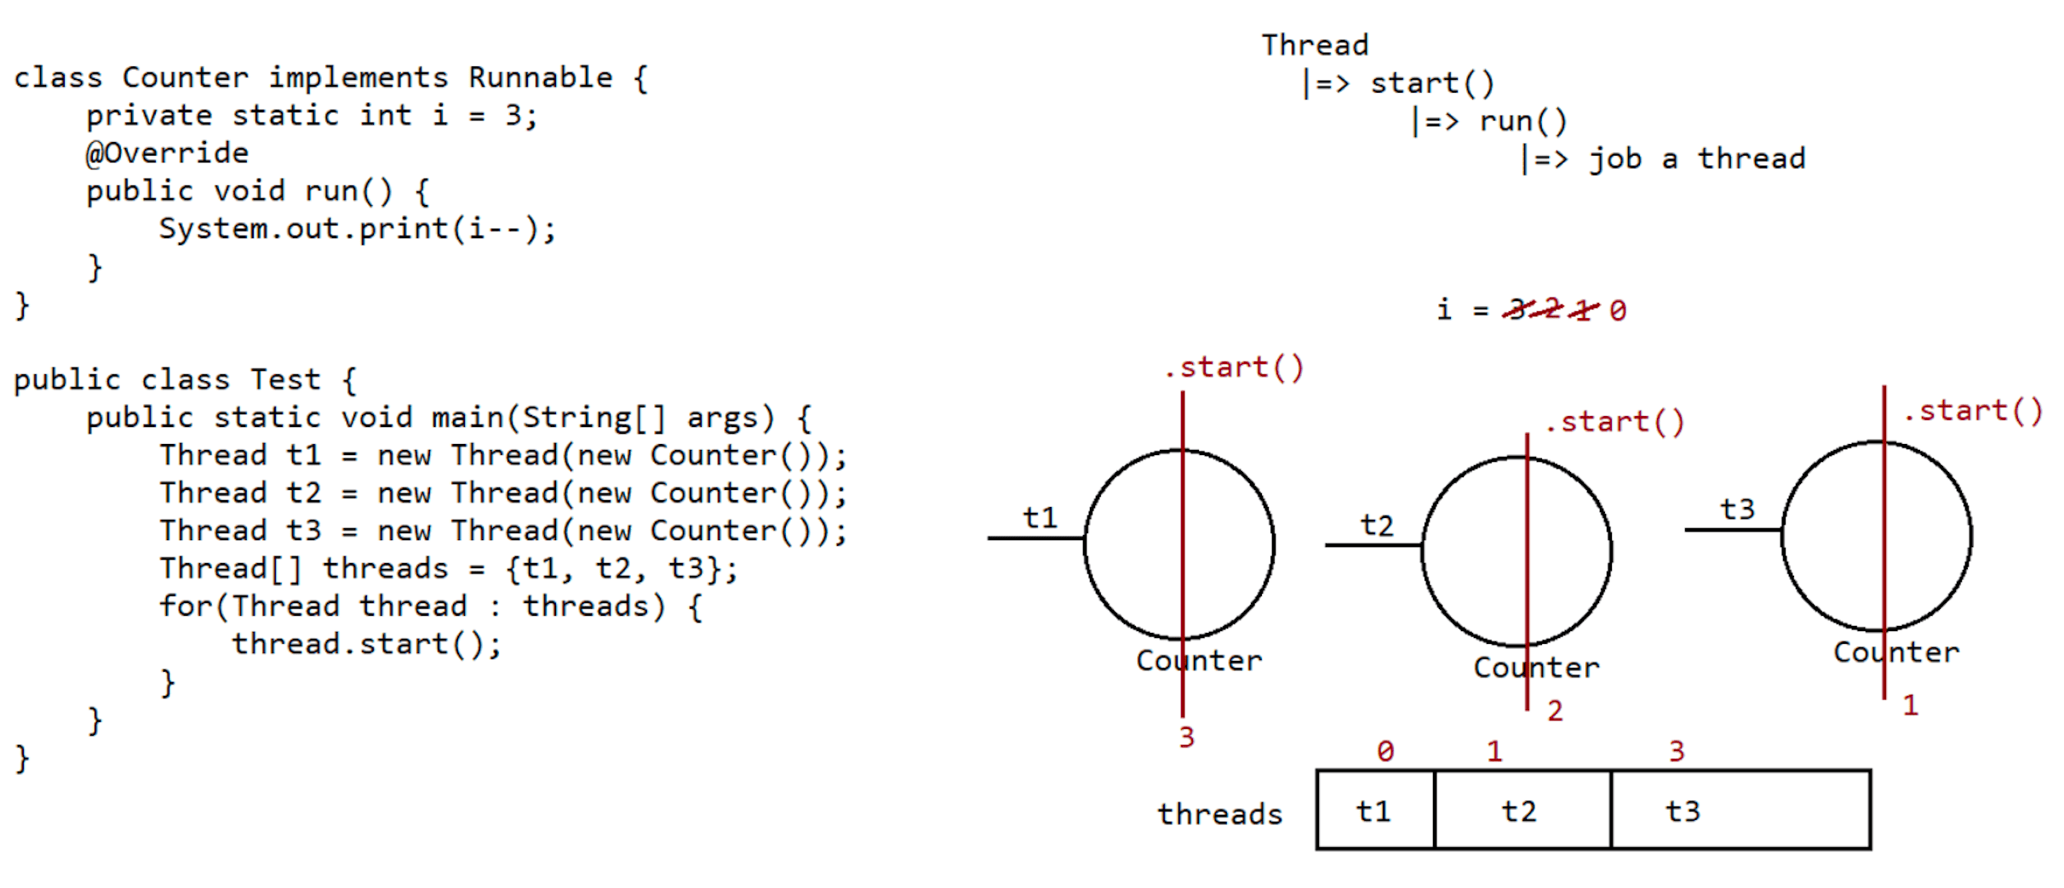
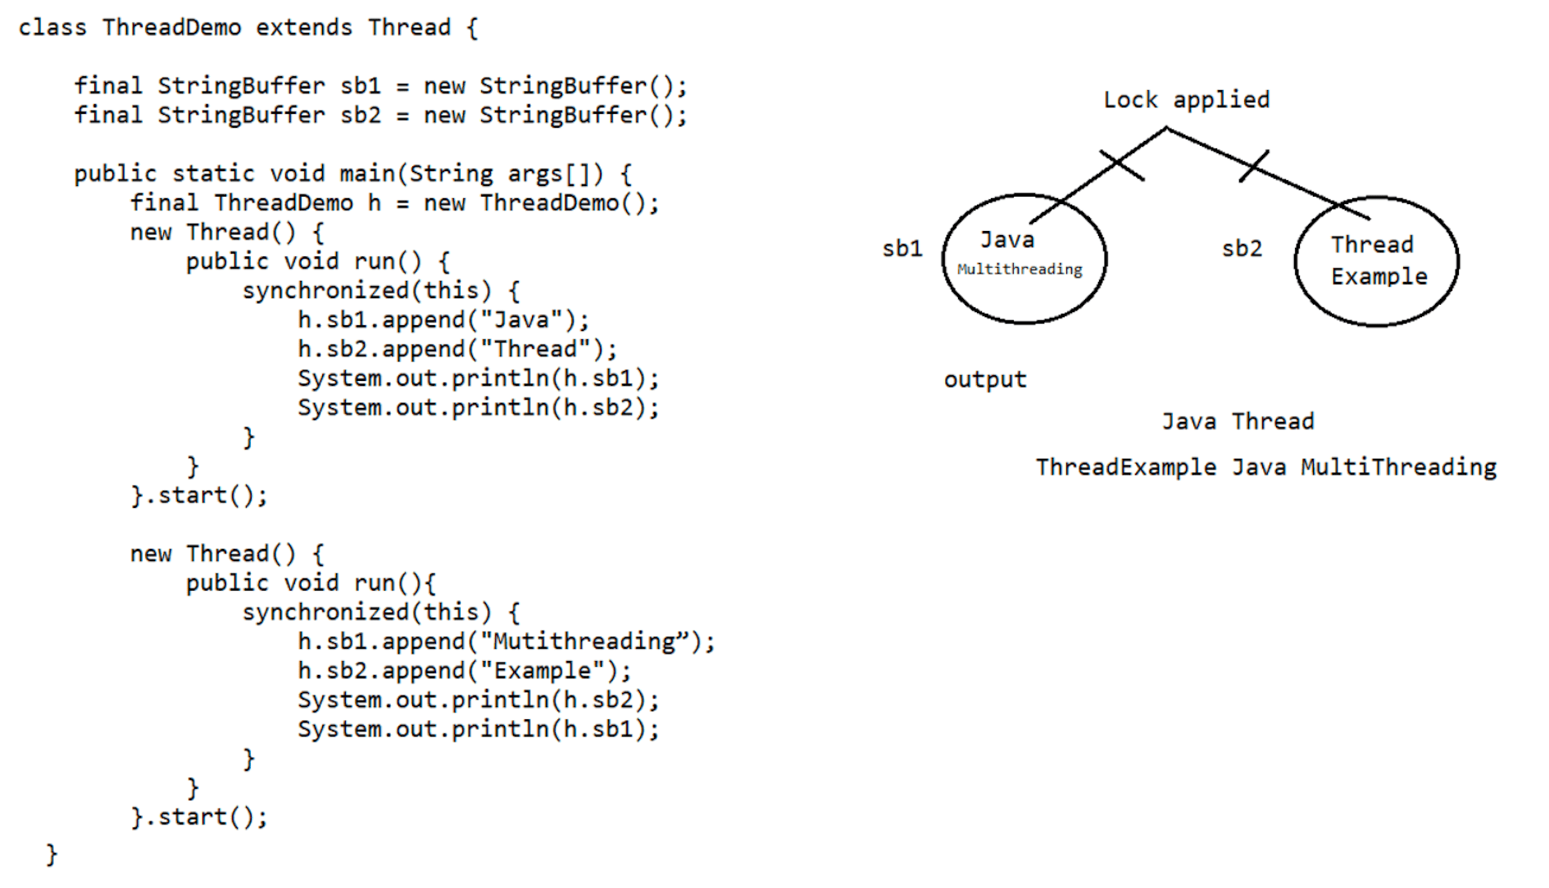

083 SQL 2

INSERT INTO studentinfo VALUES(1, 'hyder', 'abbas','najafi', 28, 'Bengaluru');

INSERT INTO studentinfo VALUES(1, 'hyder','najafi', 28, 'Bengaluru');

INSERT INTO studentinfo (id, firstname, middlename, lastname,age, city)

VALUES(1, 'hyder','abbas','najafi', 28, 'Bengaluru');

INSERT INTO studentinfo (id, firstname, lastname,age, city)

VALUES(1, 'hyder','najafi', 28, 'Bengaluru');

INSERT INTO studentinfo (id, firstname, lastname,age, city)

VALUES(?,?,?,?,?);

CREATE TABLE EMPLOYEE(

id int(5) NOT NULL,

firstname varchar(20) NOT NULL,

middlename varchar(20),

lastname varchar(20)NOT NULL,

salary int(7) NOT NULL

);

INSERT INTO employee (id, firstname, middlename, lastname,salary)

VALUES(1, 'hyder','abbas','najafi', 28);

CREATE TABLE newStudents(

id int(5) auto_increment primary key,

firstname varchar(20) NOT NULL,

middlename varchar(20),

lastname varchar(20)NOT NULL,

age int(3) NOT NULL

);

INSERT INTO newstudents (firstname, middlename, lastname,age)

VALUES('hyder','abbas','najafi', 28), ('Nitin','v','M', 28);

select * from studentinfo;

CREATE TABLE newStudents(

id INT(5) AUTO_INCREMENT PRIMARY KEY,

firstname varchar(20) NOT NULL,

middlename varchar(20),

lastname varchar(20)NOT NULL,

age int(3) NOT NULL

);

INSERT INTO newstudent1 VALUES(1,'rohan', 'hirani', 'm', 18);

create table Student(

id int(5) PRIMARY KEY,

firstname varchar(40) NOT NULL,

lastname varchar(40) NOT NULL,

age int(3) NOT NULL,

city varchar(20)NOT NULL,

country varchar(20) NOT NULL

)

INSERT INTO student (id, firstname, lastname,age, city, country)

VALUES(1,'hyder','najafi', 28,'Blr', 'IND'),

(2,'Nitin','M', 28,'Blr', 'IND');

CREATE TABLE newStudents(

id int(5) auto_increment primary key,

firstname varchar(20) NOT NULL,

middlename varchar(20),

lastname varchar(20)NOT NULL,

age int(3) NOT NULL,

number int(10) UNIQUE KEY

);

create table Student(

id int(5) PRIMARY KEY,

firstname varchar(40) NOT NULL,

lastname varchar(40) NOT NULL,

age int(3) NOT NULL,

city varchar(20)NOT NULL,

country varchar(20) NOT NULL,

number int(10) unique key,

email varchar(20) unique key

)

select * from student;

select id, firstname, city from student;

select firstname from student;

select firstname, lastname, age from student where age<20;

INSERT INTO student (id, firstname, lastname,age, city, country, number, email)

VALUES(4,'rohan','najafi', 18,'Blr', 'IND',123, 'rohan@'),

(5,'rohit','M', 19,'Blr', 'IND', 321, 'rohit@');

insert into employee (id, firstname,middlename, lastname, salary)

values(11,'rohan', 'hirani', 'b', 30000),

(21,'rohit', 'hiran', 'm', 40000),

(31,'rohi', 'h', 'meh', 50000);

create table employee(

id int(5) primary key,

firstname varchar(50) not null,

lastname varchar(50) not null,

age int(3) not null,

salary int(10)not null,

city varchar(10) not null

)

select * from employee

use ineuron;

select firstname, age from employee where salary>30000 ;

select * from employee where firstname ='ROHAN';

select firstname as name , lastname as sirname from employee;

update employee set lastname='kumar' where id=1;

update employee set age=21 where id=3

use ineuron;

update employee set city ='bengaluru' where firstname="rohan";

alter table employee drop column city;

alter table employee add primary key(id)

alter table employee add column city varchar(10)

delete from employee where id=2;

084 SQL 3

INSERT INTO studentinfo VALUES(1, 'hyder', 'abbas','najafi', 28, 'Bengaluru');

INSERT INTO studentinfo VALUES(1, 'hyder','najafi', 28, 'Bengaluru');

INSERT INTO studentinfo (id, firstname, middlename, lastname,age, city)

VALUES(1, 'hyder','abbas','najafi', 28, 'Bengaluru');

INSERT INTO studentinfo (id, firstname, lastname,age, city)

VALUES(1, 'hyder','najafi', 28, 'Bengaluru');

INSERT INTO studentinfo (id, firstname, lastname,age, city)

VALUES(?,?,?,?,?);

CREATE TABLE EMPLOYEE(

id int(5) NOT NULL,

firstname varchar(20) NOT NULL,

middlename varchar(20),

lastname varchar(20)NOT NULL,

salary int(7) NOT NULL

);

INSERT INTO employee (id, firstname, middlename, lastname,salary)

VALUES(1, 'hyder','abbas','najafi', 28);

CREATE TABLE newStudents(

id int(5) auto_increment primary key,

firstname varchar(20) NOT NULL,

middlename varchar(20),

lastname varchar(20)NOT NULL,

age int(3) NOT NULL

);

INSERT INTO newstudents (firstname, middlename, lastname,age)

VALUES('hyder','abbas','najafi', 28), ('Nitin','v','M', 28);

select * from studentinfo;

CREATE TABLE newStudents(

id INT(5) AUTO_INCREMENT PRIMARY KEY,

firstname varchar(20) NOT NULL,

middlename varchar(20),

lastname varchar(20)NOT NULL,

age int(3) NOT NULL

);

INSERT INTO newstudent1 VALUES(1,'rohan', 'hirani', 'm', 18);

create table Student(

id int(5) PRIMARY KEY,

firstname varchar(40) NOT NULL,

lastname varchar(40) NOT NULL,

age int(3) NOT NULL,

city varchar(20)NOT NULL,

country varchar(20) NOT NULL

)

INSERT INTO student (id, firstname, lastname,age, city, country)

VALUES(1,'hyder','najafi', 28,'Blr', 'IND'),

(2,'Nitin','M', 28,'Blr', 'IND');

CREATE TABLE newStudents(

id int(5) auto_increment primary key,

firstname varchar(20) NOT NULL,

middlename varchar(20),

lastname varchar(20)NOT NULL,

age int(3) NOT NULL,

number int(10) UNIQUE KEY

);

create table Student(

id int(5) PRIMARY KEY,

firstname varchar(40) NOT NULL,

lastname varchar(40) NOT NULL,

age int(3) NOT NULL,

city varchar(20)NOT NULL,

country varchar(20) NOT NULL,

number int(10) unique key,

email varchar(20) unique key

)

select * from student;

select id, firstname, city from student;

select firstname from student;

select firstname, lastname, age from student where age<20;

INSERT INTO student (id, firstname, lastname,age, city, country, number, email)

VALUES(4,'rohan','najafi', 18,'Blr', 'IND',123, 'rohan@'),

(5,'rohit','M', 19,'Blr', 'IND', 321, 'rohit@');

insert into employee (id, firstname,middlename, lastname, salary)

values(11,'rohan', 'hirani', 'b', 30000),

(21,'rohit', 'hiran', 'm', 40000),

(31,'rohi', 'h', 'meh', 50000);

create table employee(

id int(5) primary key,

firstname varchar(50) not null,

lastname varchar(50) not null,

age int(3) not null,

salary int(10)not null,

city varchar(10) not null

)

select * from employee

use ineuron;

select firstname, age from employee where salary>30000 ;

select * from employee where firstn

ame ='ROHAN';

select firstname as name , lastname as sirname from employee;

update employee set lastname='kumar' where id=1;

update employee set age=21 where id=3

use ineuron;

update employee set city ='bengaluru' where firstname="rohan";

alter table employee drop column city;

alter table employee add primary key(id)

alter table employee add column city varchar(10)

delete from employee where id=2;

delete from employee where id=2;

set auto_commit=0;

use ineuron;

set sql_safe_updates=0;

delete from studentinfo;

select * from studentinfo;

rollback;

set autocommit=0;

use ineuron;

set sql_safe_updates=0;

delete from student;

rollback;

select * from student;

truncate student;

select * from student;

rollback;

select * from student;

select * from employee;

select UPPER("ineuron");

select LOWER('IneuRon');

select UPPER(firstname) from employee;

select substr(firstname, 1,2) as shortName from employee;

select substring('ineuron',2,4 );

select abs(-20);

select pow(2,4);

insert into employee (id, firstname, lastname, age,salary, city)

values(11,'rohan', 'hirani',22, 30000,'blr' ),

(21,'rohit', 'hiran', 23, 40000, 'pune'),

(31,'rohi', 'h', 24, 50000, 'nagpur');

update employee set city='Mumbai' where id=2;

select firstname, lastname from employee where age between 18 and 22;

select firstname, lastname from employee where age>18 and age<24;

select * from employee order by salary asc;

select * from employee order by salary desc;

select * from employee where age>21 and age< 24 order by salary desc;

select * from employee where age not between 19 and 23 order by salary desc;

select * from employee where age between 19 and 23 order by salary desc;

select distinct firstname from employee;

select distinct city from employee;

create table studentinfo

(

id int(5) primary key,

name varchar(50) not null,

age int(3) not null,

course int(10) ,

foreign key(course) references Course(cid)

);

create table course (

crid int(3) primary key,

crname varchar(10)

)

insert into course (crid, crname) values(1,'java'),(2,'sql'),

(3,'python'), (4,'js');

select * from studentinfo inner join course on studentinfo.course = course.crid;

select * from studentinfo si inner join course cr on si.course = cr.crid;

select id, name, age , crname from studentinfo

si inner join course cr

on si.course = cr.crid

where si.age>18

order by si.name ;

select id, name, age , crname from studentinfo

si right join course cr

on si.course = cr.crid ;

select id, name, age , crname from studentinfo

si left join course cr

on si.course = cr.crid ;

select columns from t1 inner join table2 t2 on t1.colname=t2.colname inner join table 3 t3

on t1.colname=t3.colname;

086 JDBC 1

With core java knowledge we can build standalone applications
Standalone applications
====================
The applications which are running on single machine are called as "Standalone
applications".
eg: Calculator, MS-word, notepad,....
If we want to develop web-applications then we need to go for "Advanced Java".
What are webapplications?
The application which provide service over the web/internet are called as
"WebApplications".
eg: gmail.com, facebook.com,ineuron.ai,telusko.com,.......
In java we can develop webapplications using the following technologies
a. JDBC
b. Servlet
c. JSP/Thymeleaf
JDBC(Java Database Connectivity)
For a Java Application(Normal java class or Servlet) if we want to
communicate with database, then we need to go for
JDBC.
eg: To get mails information from database
To get Astrology information from Database
Servlet
Whenever some processing logic is required then we need to go for Servlet.
Servler is meant for Processing logic/Buisness Logic.
eg: Verify user
Communicate with the data
Process end user data
JSP
Whenever presentation logic is required todisplay something to the end user
then we need to go for jsp
Jsp stands for View Component
eg: display login page
display inbox page
display error page
display result page
JDBC
The current version of JDBC is 4.X(4.2V)
JDK s/w required => jdk8 and above
Steps given by SUNMS to communicate with Database
=============================================
1. Load and register the Driver.
2. Establish the connection with Database.
3. Create Statement Object and execute the Query.
4. Process the ResultSet.
5. Handle the SQLException if it gets generated.
6. Close the Connection.
1. Load and register the DriverWe need to load and register the Driver as per the DB requirement.
As per the DB specification, we need to set the JRE environment with
the DB environment.
Any class of DB vendor, we say at is Driverclass, iff it has
implemented a interface called "Driver".
MySQL =======> The implementation class of MySQLjar is "Driver".
2. Establish the Connection with database
public static Connection getConnection(String, java.util.Properties) throws
java.sql.SQLException;
public static Connection getConnection(String, String, String) throws
java.sql.SQLException;
public static Connection getConnection(String) throws java.sql.SQLException;
Connection connection = DriverManager.getConnection(url,username,password);
The above line would create connection Object,but Connection is an interface,can
object to interface be created?
Answer: No, for an interface instantiation is not possible.
In this line, an Object to a class which implements an interface
called Connection is created and we hold the
the reference of the object with the interface name.
This is done to promote loose coupling in java.
The above code would also represent "abstraction".
3.Create Statement Object and execute the Query.
Statement statement = connection.createStatement();
The above line would create statement Object,but Statement is an interface,can
object to interface be created?
Answer: No, for an interface instantiation is not possible.
In this line, an Object to a class which implements an interface
called Statement is created and we hold the
the reference of the object with the interface name.
This is done to promote loose coupling in java.
The above code would also represent "abstraction".
ResultSet resultSet =statement.executeQuery(sqlSelectQuery);
The above line would create statement Object,but ResultSet is an interface,can
object to interface be created?
Answer: No, for an interface instantiation is not possible.
In this line, an Object to a class which implements an interface
called ResultSet is created and we hold the
the reference of the object with the interface name.
This is done to promote loose coupling in java.
The above code would also represent "abstraction".
jdbc pgm to retrieve all records from database
======================================
import java.sql.*;
class TestApp {
public static void main(String[] args) {
Connection connection = null;
Statement statement = null;
ResultSet resultSet = null;
try{//Step1. Load and register the Driver
Class.forName("com.mysql.cj.jdbc.Driver");
System.out.println("Driver loaded succesfully....");
//Step2. Establish the Connection with database
String url = "jdbc:mysql://localhost:3306/octbatch";
//username and password would vary from user to user
String userName = "root";
String passWord = "root123";
connection = DriverManager.getConnection(url,userName,passWord);
System.out.println("connection established succesfully...");
System.out.println("The implement class name is "+
connection.getClass().getName());
//Step3. Create statement Object and send the query
String sqlSelectQuery = "select sid,sname,sage,saddress from
student";
statement = connection.createStatement();
System.out.println("The implementation class name
is ::"+statement.getClass().getName());
resultSet =statement.executeQuery(sqlSelectQuery);
System.out.println("The implementation class name
is ::"+resultSet.getClass().getName());
System.out.println();
System.out.println("SID\tSNAME\tSAGE\tSADDRESS");
//Step4. Process the resultSet
while (resultSet.next())
{
Integer sid = resultSet.getInt(1);
String sname = resultSet.getString(2);
Integer sage = resultSet.getInt(3);
String saddr = resultSet.getString(4);
System.out.println(sid+"\t"+sname+"\t"+sage+"\t"+saddr);
}
}catch (ClassNotFoundException ce){
ce.printStackTrace();
}catch(SQLException se){
se.printStackTrace();
}catch(Exception e){
e.printStackTrace();
}finally{
//closing the resources
if (connection!=null)
{
try
{
}
connection.close();
System.out.println("Connection closed...");
catch (SQLException se){se.printStackTrace();
}
}
}
}
}
output
D:\jdbcoctbatch>echo %path%
C:\Program Files\Java\jdk1.8.0_202\bin
D:\jdbcoctbatch>echo %classpath%
;.;D:\jars\mysql-connector-j-8.0.31.jar
D:\jdbcoctbatch>javac TestApp.java
D:\jdbcoctbatch>java TestApp
Driver loaded succesfully....
connection established succesfully...
The implement class name is com.mysql.cj.jdbc.ConnectionImpl
The implementation class name is ::com.mysql.cj.jdbc.StatementImpl
The implementation class name is ::com.mysql.cj.jdbc.result.ResultSetImpl
SID SNAME SAGE SADDRESS
1 sachin 50 MI
2 kohli 35 RCB
3 dhoni 41 CSK
4 rahul 28 LSG
5 SKY 28 DC
Connection closed...
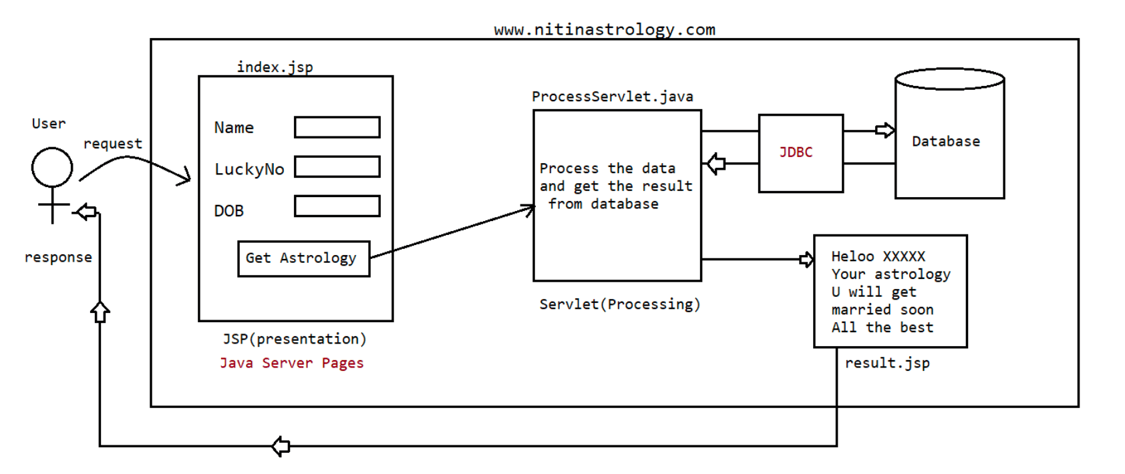
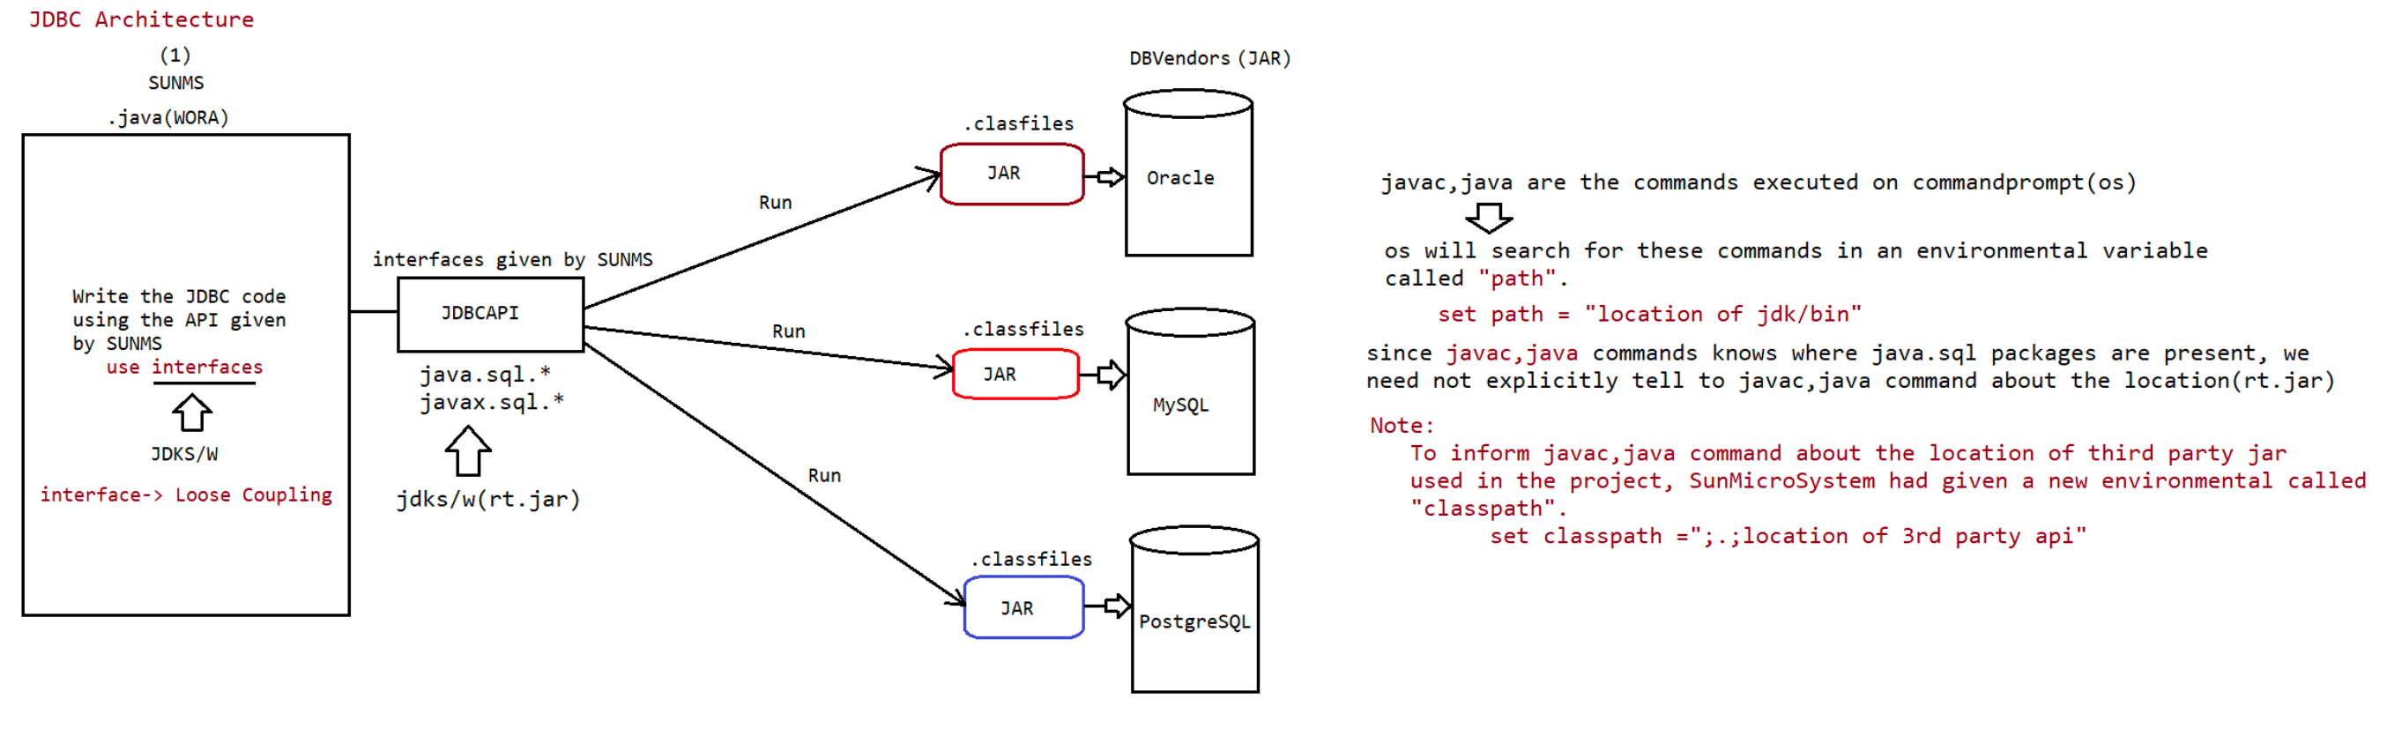
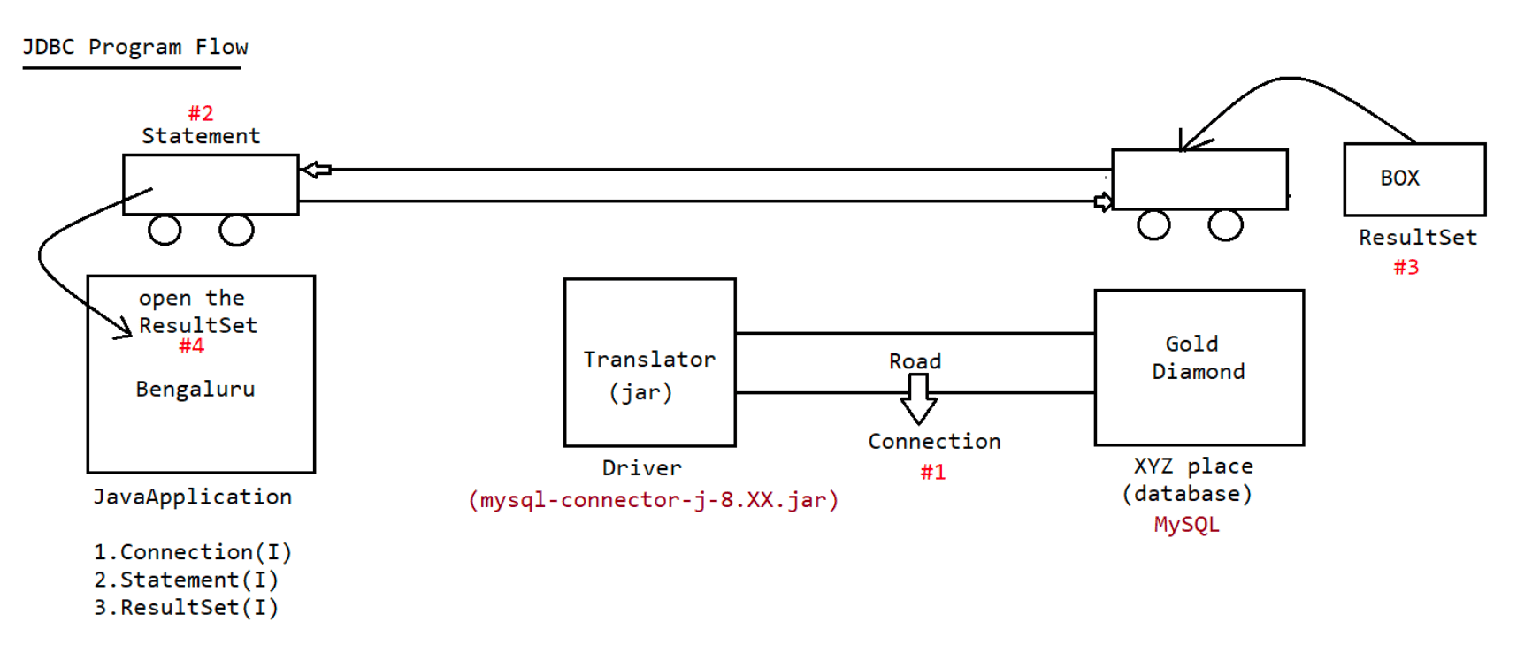
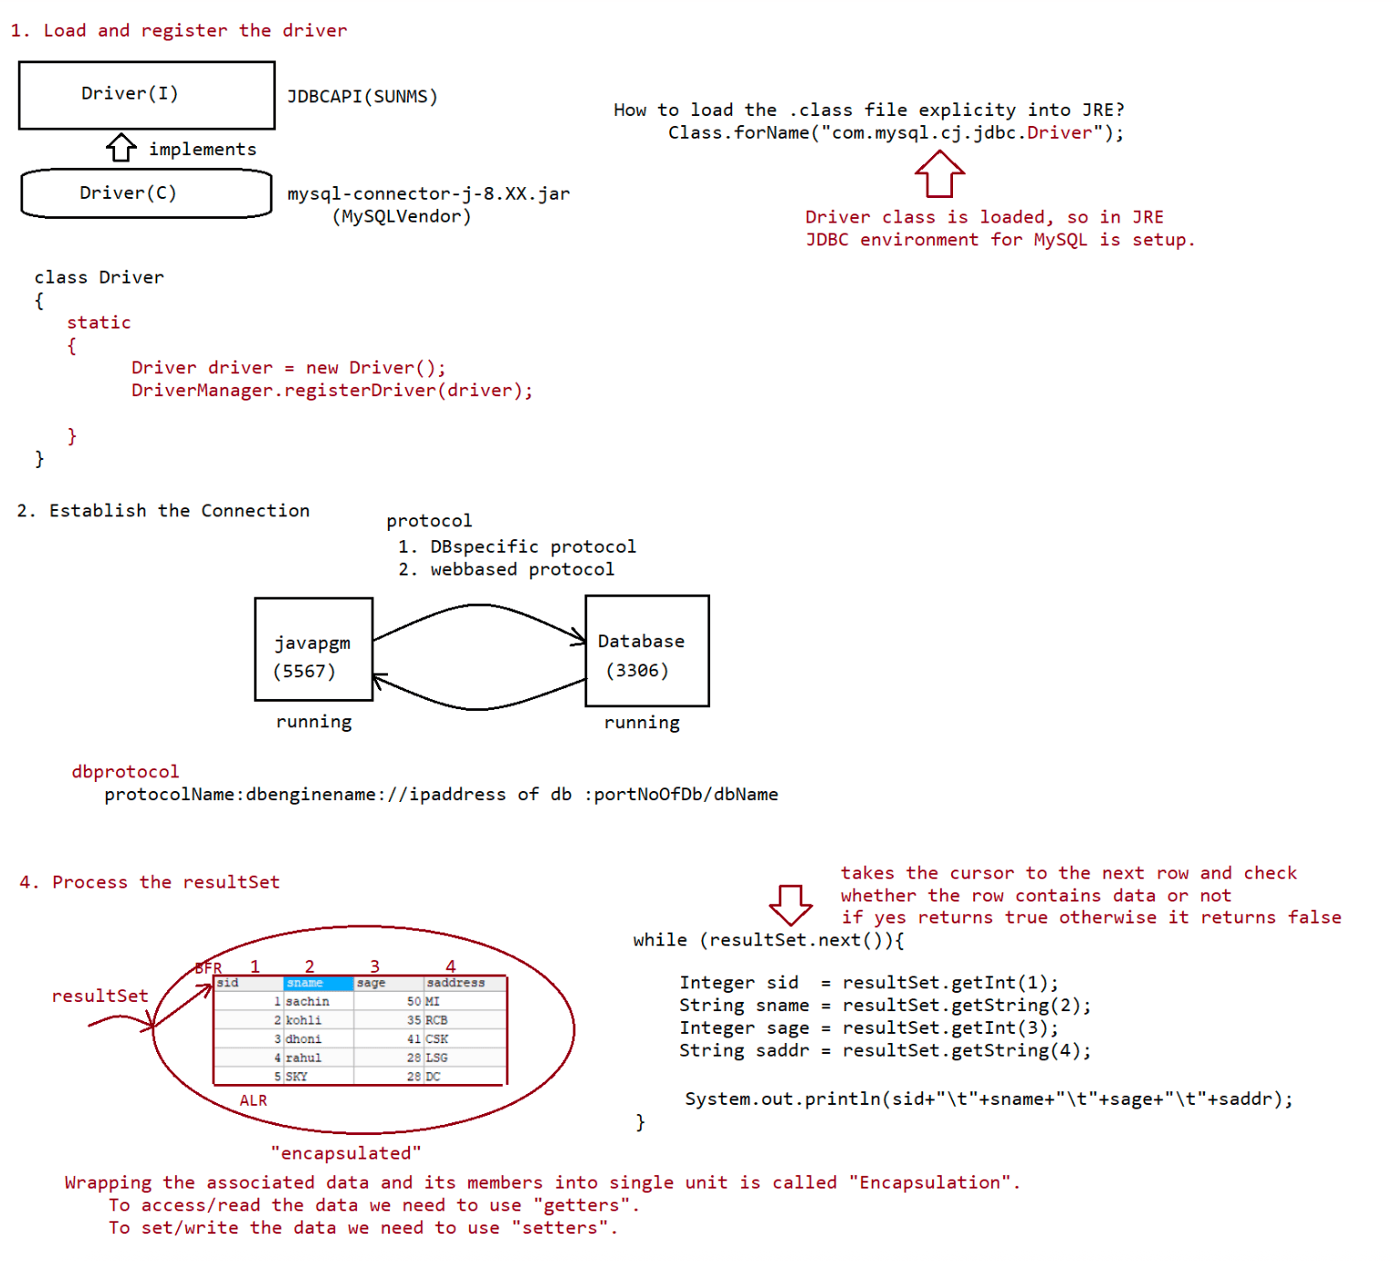

087 JDBC 2

From JDBC4.X version onwards,there is a facility of "autoloading".
Q> What is autoloading in JDBC?
Loading and register the driver is done automatically,based on the url
supplied by the user.
Behind the scenes
a. check the url
b. based on the url supplied, go to classpath environmental variable
c. open the relevant jar
d. go to META-INF/services folder
e. open java.sql.Driver file
f. read the file and load the class supplied in the file
Note:
Using resultSet object, we can retrieve the records based on the column names
also.
If java pgm and database engine is running in the same program with the default
port no for database then
url can be of the following type
String url = "jdbc:mysql:///octbatch".
Program to demonstrate select operation using JDBC
==========================================
package in.ineuron.main;
import java.sql.Connection;
import java.sql.DriverManager;
import java.sql.ResultSet;
import java.sql.SQLException;
import java.sql.Statement;
//JDBC4.X autoloading feature is enabled.
public class SelectApp {
public static void main(String[] args) throws ClassNotFoundException,
SQLException {
// Step2. Establish the Connection
String url = "jdbc:mysql:///octbatch";
String user = "root";
String password = "root123";
Connection connection = DriverManager.getConnection(url, user,
password);
System.out.println("CONNECTION object created...");
// Step3. Create statement Object and send the Query
Statement statement = connection.createStatement();
System.out.println("STATEMENT object created...");
// Step4. Execute the Query and Process the resultSet
String sqlSelectQuery = "select sid,sname,sage,saddress from student";
ResultSet resultSet = statement.executeQuery(sqlSelectQuery);
System.out.println("RESULTSET object created...");
System.out.println("SID\tSNAME\tSAGE\tSADDRESS");
while (resultSet.next()) {
int sid = resultSet.getInt("sid");
String sname = resultSet.getString("sname");int sage = resultSet.getInt("sage");
String saddress = resultSet.getString("saddress");
System.out.println(sid + "\t" + sname + "\t" + sage + "\t" +
saddress);
}
// Step6. Close the resources
resultSet.close();
statement.close();
connection.close();
System.out.println("Closing the resources...");
}
}
Output
Loading the driver...
CONNECTION object created...
STATEMENT object created...
RESULTSET object created...
SID SNAME SAGE SADDRESS
1 sachin 50 MI
2 kohli 35 RCB
3 dhoni 41 CSK
4 rahul 28 LSG
5 SKY 28 DC
Closing the resources...
Note
types
According to DBA specification, all SQL commands are categorised into following
a. DDL(Data Definition Language)
eg: Create table, alter table, drop table, etc...
b. DML(Data Manipulation Language)
eg: insert,update,delete
c. DQL(Data Query Language)
eg: Select
d. DCL(Data Control Language)
eg: Alter password, grant access,....
e. DA command(Database Administrator commands)
eg: start audit
stop audit
f. TCL(Transaction Control Language)
eg: commit, rollback,savepoint,....
According to Java Developer point of view, all SQL operations are classified into 2
types
a. Select operation(DQL)
b. Non-Select Operation(DML,DDL,...)
Through Statement Object we need to execute the Query and to exectue the Query we
need to make a call
to a method as shown below.
a. executeQuery()
b. executeUpdate()
c. execute()
a. executeQuery()
This method is used only if we perform select operation.Because of this method execution, we will get a group of records which are
represented as "ResutlSet" object.
public ResultSet executeQuery(String sqlSelectQuery) throws
SQLException;
eg: ResultSet resultSet =statement.executeQuery("select
sid,sname,sage,saddress from student");
b. executeUpdate()
This method is used for "Non-Select Operations" like(Insert|Update|Delete)
Because of this method execution, we won't get group of records, we will get
a numeric value which represents
the number of rows affected. So return type of the method is "int".
public int executeUpdate(String sqlNonSelectQuery) throws
SQLException;
eg: int rowAffected = statement.executeUpdate("delete from
student where sid = 10");
System.out.println("No of rows affected is ::
"+rowAffected);
c. execute()
we can use this method for both select and nonselect operation
if we don't know the type of query at the begining and if is available
dynamically at the runtime then we need to use
this method for execution.
public boolean execute(String sql) throws SQLException;
eg: boolean value = statement.execute(dynamicQuery);
if(value == true)
{
//select Query
ResultSet resultSet = statement.getResultSet();
//process the resultSet
}
else
{
//nonSelect Query
int rowCount = statement.getUpdateCount();
System.out.println("Number of rows affected
is :: "+rowCount);
}
Formatting SQlQueries using dynamic input
===================================
1st approach
==========
sname = scanner.next();
sage =scanner.nextInt();
saddress = scanner.next();
String sqlInsertQuery = "insert into
student(`sname`,`sage`,`saddress`)values('"+sname+"',"+sage+",'"+saddress+"')";
2nd approach
===========
sname = scanner.next();
sage =scanner.nextInt();
saddress = scanner.next();
sname = "'"+sname+"'";
saddress = "'"+saddress+"'";String sqlInsertQuery = "insert into
student(`sname`,`sage`,`saddress`)values("+sname+","+sage+","+saddress+")";
3rd approach
===========
The above 2 approaches are not recomended, to do formatting we prefer using
String class format() as shown below.
public static String format(String format, Object... args)
sname = scanner.next();
sage =scanner.nextInt();
saddress = scanner.next();
String sqlInsertQuery =String.format("insert into
student(`sname`,`sage`,`saddress`) values ('%s',%d,'%s')",
sname,sage,saddress);
Write a JDBC code to take dynamic input from the user to perform insert operation
package in.ineuron.main;
import java.sql.Connection;
import java.sql.DriverManager;
import java.sql.SQLException;
import java.sql.Statement;
import java.util.Scanner;
//JDBC4.X autoloading feature is enabled.
public class InsertApp {
public static void main(String[] args) throws SQLException {
// Step2. Establish the Connection
String url = "jdbc:mysql:///octbatch";
String user = "root";
String password = "root123";
Connection connection = DriverManager.getConnection(url, user,
password);
System.out.println("connection object created...");
// Step3. Create statement Object and send the Query
Statement statement = connection.createStatement();
System.out.println("statement object created...");
Scanner scanner = new Scanner(System.in);
System.out.print("Enter the name of the student :: ");
String sname = scanner.next();
System.out.print("Enter the age of the student :: ");
int sage = scanner.nextInt();
System.out.print("Enter the address of the student :: ");
String address = scanner.next();
System.out.print("Enter the gender of a student:: ");
String gender = scanner.next();
// Step4. Execute the Query and Process the resultSet
String sqlInsertQuery = String.format("insert into
student(`sname`,`sage`,`saddress`,`sgender`) values ('%s',%d,'%s','%s')",sname, sage, address,gender);
System.out.println(sqlInsertQuery);
int rowAffected = statement.executeUpdate(sqlInsertQuery);
System.out.println("No of rows affected is :: " + rowAffected);
// Step6. Close the resources
statement.close();
connection.close();
scanner.close();
System.out.println("closing the resources...");
}
}
Output
connection object created...
statement object created...
Enter the name of the student :: mandana
Enter the age of the student :: 27
Enter the address of the student :: kodagu
Enter the gender of a student:: F
insert into student(`sname`,`sage`,`saddress`,`sgender`) values
('mandana',27,'kodagu','F')
No of rows affected is :: 1
closing the resources...
Note:
While writing JDBC code, the following steps are common
a. Establishing the connection
b. closing the resources
c. handling the exception
What would vary in every code is
a. query will be different
1. if it select process the ResultSet object.
2. if it non-select, process the integer value.
For the above 3 steps, the common util code is as shown below
package in.ineuron.util;
import java.sql.Connection;
import java.sql.DriverManager;
import java.sql.ResultSet;
import java.sql.SQLException;
import java.sql.Statement;
public class JdbcUtil {
private JdbcUtil() {
}
static {
try {
//Step1: loading and register the Driver
Class.forName("com.mysql.cj.jdbc.Driver");
} catch (ClassNotFoundException ce) {
ce.printStackTrace();}
}
public static Connection getJdbcConnection() throws SQLException {
// Step2. Establish the Connection
String url = "jdbc:mysql:///octbatch";
String user = "root";
String password = "root123";
Connection connection = DriverManager.getConnection(url, user,
password);
System.out.println("connection object created...");
return connection;
}
public static void cleanUp(Connection con, Statement statement, ResultSet
resultSet) throws SQLException {
// Step6. Close the resources
if (con != null) {
con.close();
}
if (statement != null) {
statement.close();
}
if (resultSet != null) {
resultSet.close();
}
}
}
Note:
In the above code, the url pattern, username and password is hardcode.
These values would vary from user to user.
To set these values, we use properties file approach as shown below.
package in.ineuron.util;
import java.io.FileInputStream;
import java.io.IOException;
import java.sql.Connection;
import java.sql.DriverManager;
import java.sql.ResultSet;
import java.sql.SQLException;
import java.sql.Statement;
import java.util.Properties;
public class JdbcUtil {
private JdbcUtil() {
}
static {
try {
// Step1: loading and register the Driver
Class.forName("com.mysql.cj.jdbc.Driver");
} catch (ClassNotFoundException ce) {
ce.printStackTrace();
}
}public static Connection getJdbcConnection() throws SQLException, IOException
{
// Take the data from properties file
FileInputStream fis = new FileInputStream("D:\\octbatchjdbcpgm\\
JDBCStandardApp\\application.properties");
Properties properties = new Properties();
properties.load(fis);
// Step2. Establish the Connection
Connection connection =
DriverManager.getConnection(properties.getProperty("url"),
properties.getProperty("username"),
properties.getProperty("password"));
System.out.println("connection object created...");
return connection;
}
public static void cleanUp(Connection con, Statement statement, ResultSet
resultSet) throws SQLException {
// Step6. Close the resources
if (con != null) {
con.close();
}
if (statement != null) {
statement.close();
}
if (resultSet != null) {
resultSet.close();
}
}
}
application.properties
==================
url=jdbc:mysql:///octbatch
username=root
password=root123

088 JDBC 3

Properties
========
It represents the data in the form of K,V pair
It represents an object of type java.util.Properties
Properties object holds the data which would be changing frequently in our
application.
Program to demonstrate the usage of Properties object in java
==================================================
import java.io.*;
import java.util.*;
class PropertiesApp
{
public static void main(String[] args)throws Exception
{
FileInputStream fis = new FileInputStream("application.properties");
Properties properties = new Properties();
properties.load(fis);
String url = properties.getProperty("url");
String user = properties.getProperty("user");
String password = properties.getProperty("password");
System.out.println("URL IS ::"+url);
System.out.println("USER IS ::"+user);
System.out.println("PWD IS ::"+password);
}
}
application.properties
==================
url =jdbc:oracle:thin:@localhost:1521:XE
user=System
password=root123
Output
D:\jdbcoctbatch>javac PropertiesApp.java
D:\jdbcoctbatch>java PropertiesApp
URL IS ::jdbc:mysql:///octbatch
USER IS ::root
PWD IS ::root123
D:\jdbcoctbatch>java PropertiesApp
URL IS ::jdbc:oracle:thin:@localhost:1521:XE
USER IS ::System
PWD IS ::root123
PrepardStatement(I)
================
public abstract PreparedStatement prepareStatement(String query) throws
SQLException;
While using PreparedStatement the query woudl be as shown below
String sqlInsertQuery ="insert into
student(`sname`,`sage`,`saddress`,`sgender`)values(?,?,?,?)";
PreparedStatement pstmt = con.prepareStatement(sqlInsertQuery);//query compiled ready for execution
pstmt.setString(1,"apeksha");
pstmt.setInt(2,26);
pstmt.setString(3,"MI");
pstmt.setString(4,"F");
int rowCount = pstmt.executeUpdate();
refer: JDBCPreparedStatementApp
JDBC Project Requirement
=====================
1. Develop a console based application in the following manner
a. Create a menu for the user to perform CRUD operation as shown below
1. Press 1 for Insert operation
2. Press 2 for select operation
3. Press 3 for Update operation
4. Press 4 for Delete operation
5. Press 5 for exit
Note: anything above 5 tell invalid operation
b. If user presses 1
a. Take inputs from the user to accept the data like
1. sid(pk) 2. sname 3. sage 4. saddress
b. perform insertion operation
c. display suitable message as
a. record inserted succesfully
b. record insertion failed
c. If user presses 2
a. Take inputs from the user to accept the data like
1. sid(pk)
b. perform select operation
c. display suitable message as
a. display the details in table format.
b. record not available for the given id.
d. b. If user presses 3
a. Take inputs from the user to accept the data like
1. sid(pk)
b. for the entered id display the details first
sid : XXXXX (no change becoz it is pk)
sname : XXXXX enter new sname :: XXXXX
sage : XXXXX enter new sage :: YYYYY
saddr : XXXXX enter new saddr :: YYYYY
c. display suitable message as
a. record updated succesfully
b. record updation failed
e. If user presses 4
a. Take inputs from the user to accept the data like
1. sid(pk)
b. perform delete operation
c. display suitable message as
a. record deleted succesfully.
b. record not available for the given id.
Advantages of PreparedStatement
=============================1. Performance is very high compared to Statement approach becoz query will be
compiled only once.
2. Since we don't send the query multiple times b/w java application and database
traffic will be reduced.
3. inputs to the query need not be supplied at the begining dynamically we can
supply the inputs.
4. inputs to the query can be supplied just like java style, no need to perform
formatting as per the DB specification.
5. Best suitable for inserting Date values.
6. Best sutiable for insertion of BLOB's and CLOB's (image and pdf files).
7. It prevents SQLInjection Attack.
Limitation of PreparedStatement
===========================
Statement stmt = connection.createStatement();//[samsung phone ---->
airtelsim,jiosim,vi]GSMA
stmt.executeUpdate("insert into student values ()...");
stmt.executeQuery("select * from student");
stmt.executeUpdate("delete from student wher....");
One statement object can be used to execute mulitple query but with no change
in inputs.
PreparedStatement pstmt = connection.prepareStatement("select * from
student");//[Jio Phone----> jio sim]CDMA
pstmt.executeQuery();
One PreparedStatement object is restricted to only one query, that query can
be executed multiple times
with change in input.
Which of the following represent valid statements ?
1. delete from employee where ename = ?(valid)
2. delete from employee ? ename = ? (invalid)
3. delete from ? where ename = ? (invalid)
4. delete ? employees where ename = ?(invalid)
Note: we can use ? only in the place of input values and we cannot use in the place
of sql keywords, tablenames
and column names.
Static query vs Dynamic query
========================
The sql query without positional parameter(?) is called static query.
eg: delete from employee where ename = 'sachin';
The sql query with positional parameter(?) is called dynamic query
eg: delete from employee where ename = ?
select eid,ename,esal from employee where esal > ?
Note:
Simple Statement object can be used for static queries, where as Preparedstatement
object can be used for static queries
and dynamic queries also.
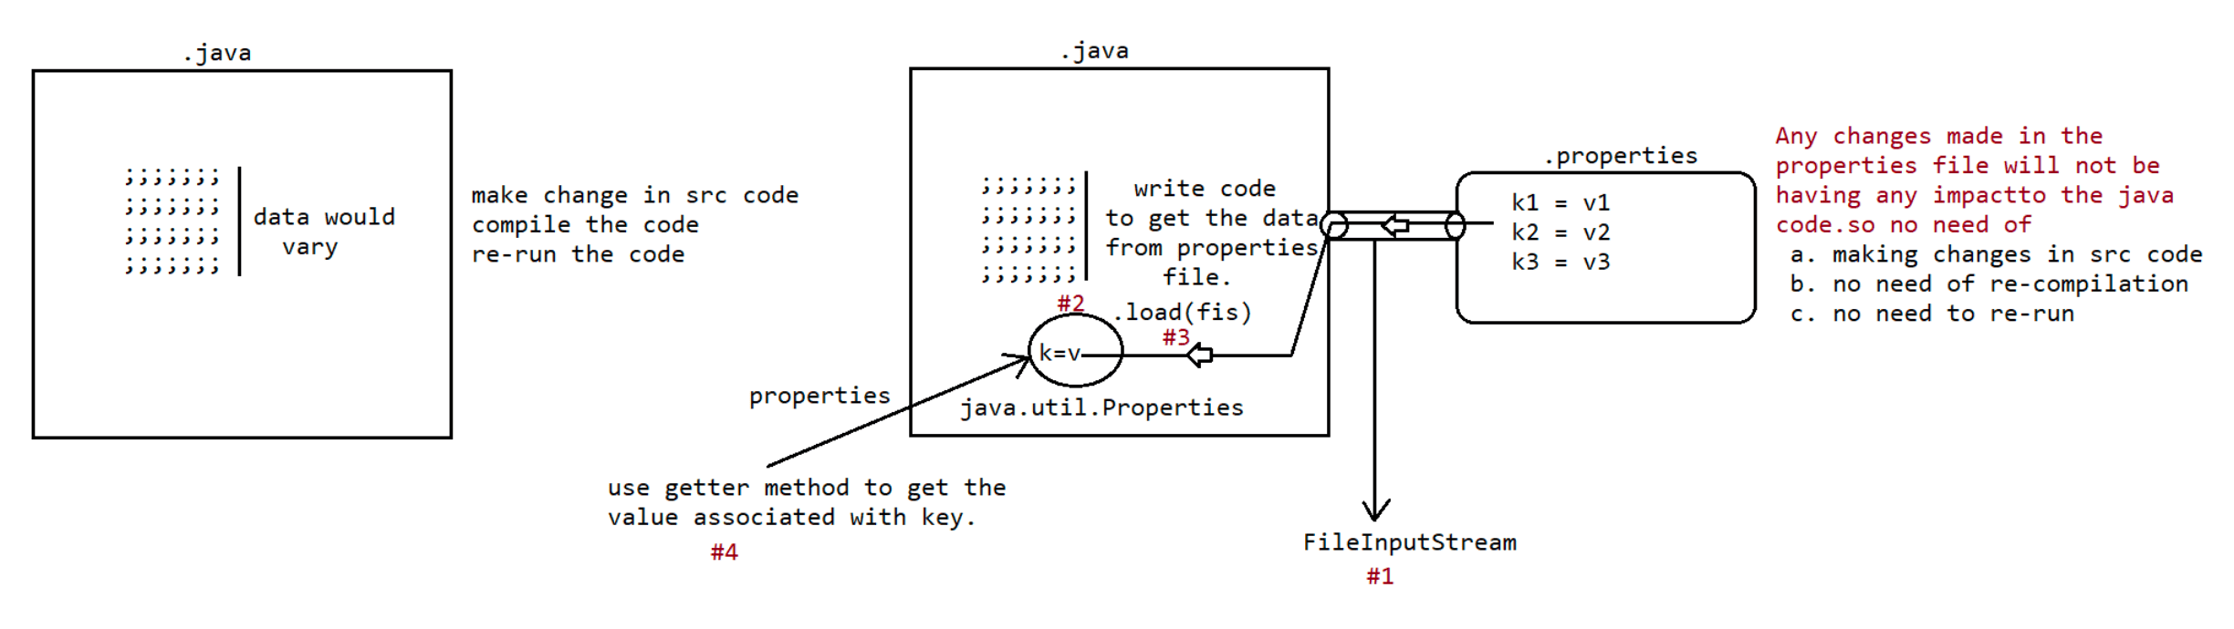
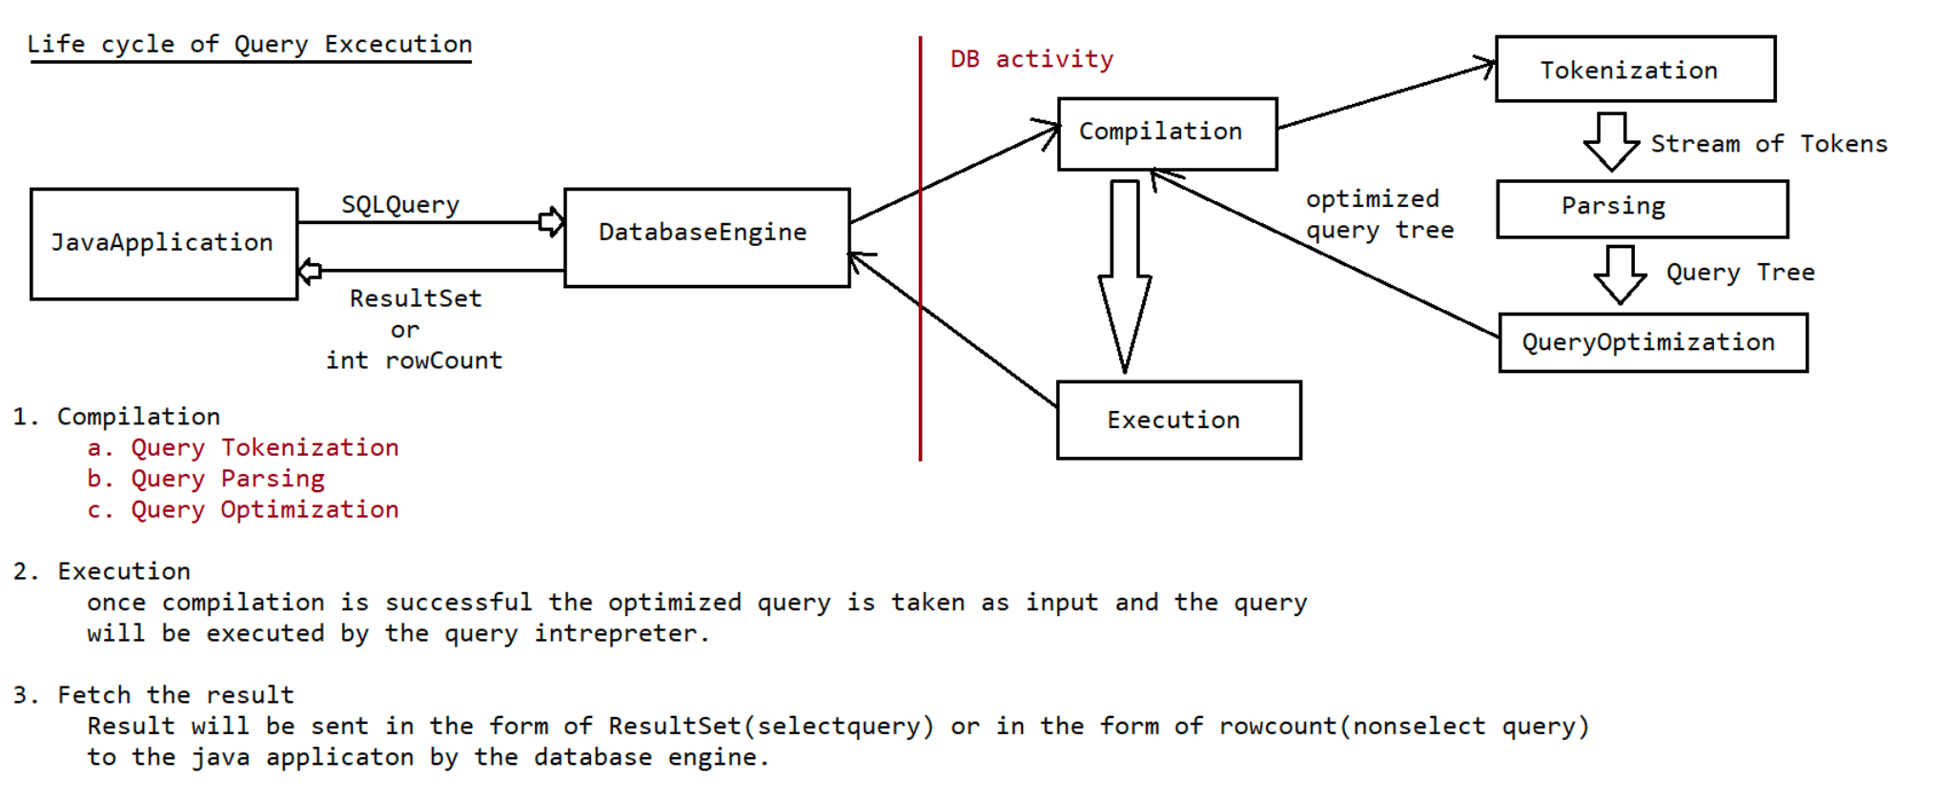
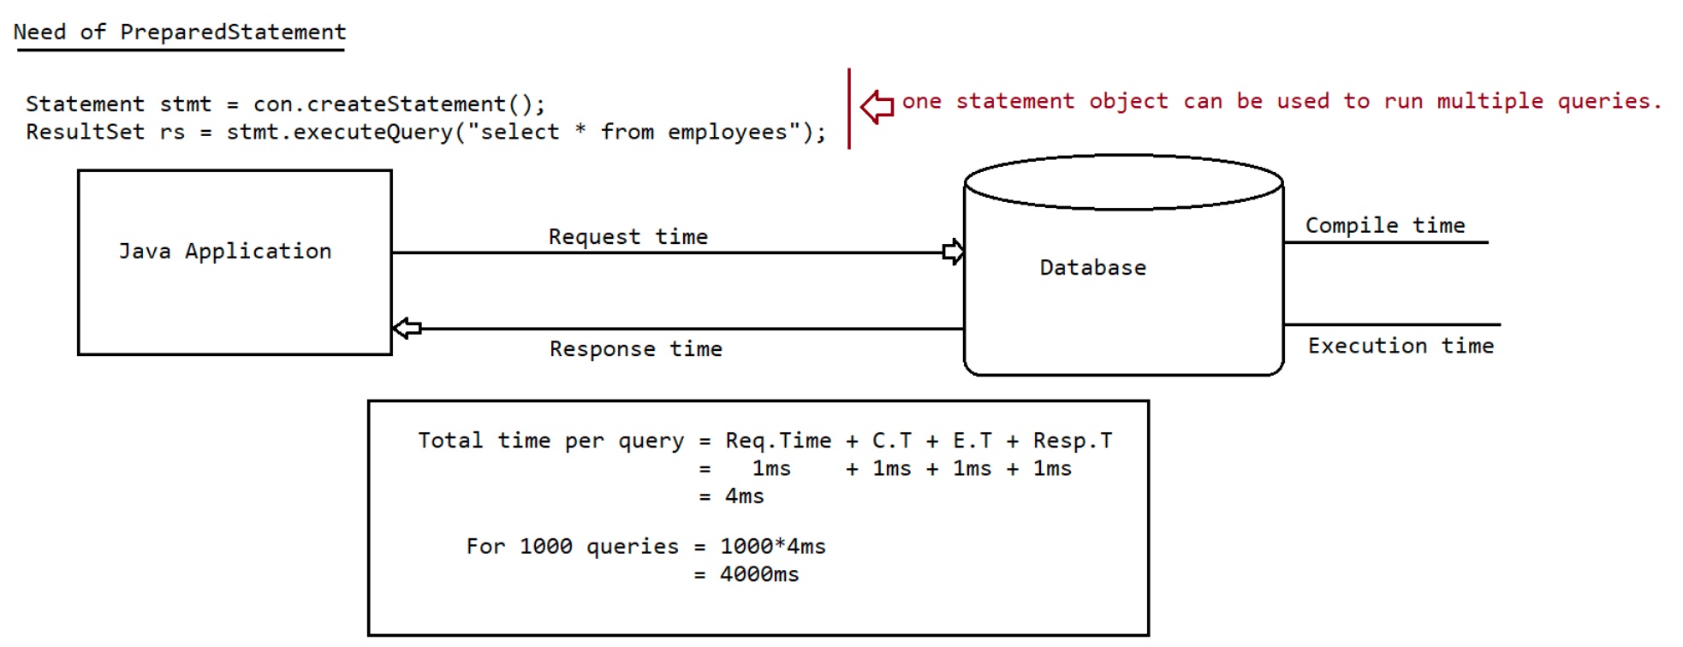
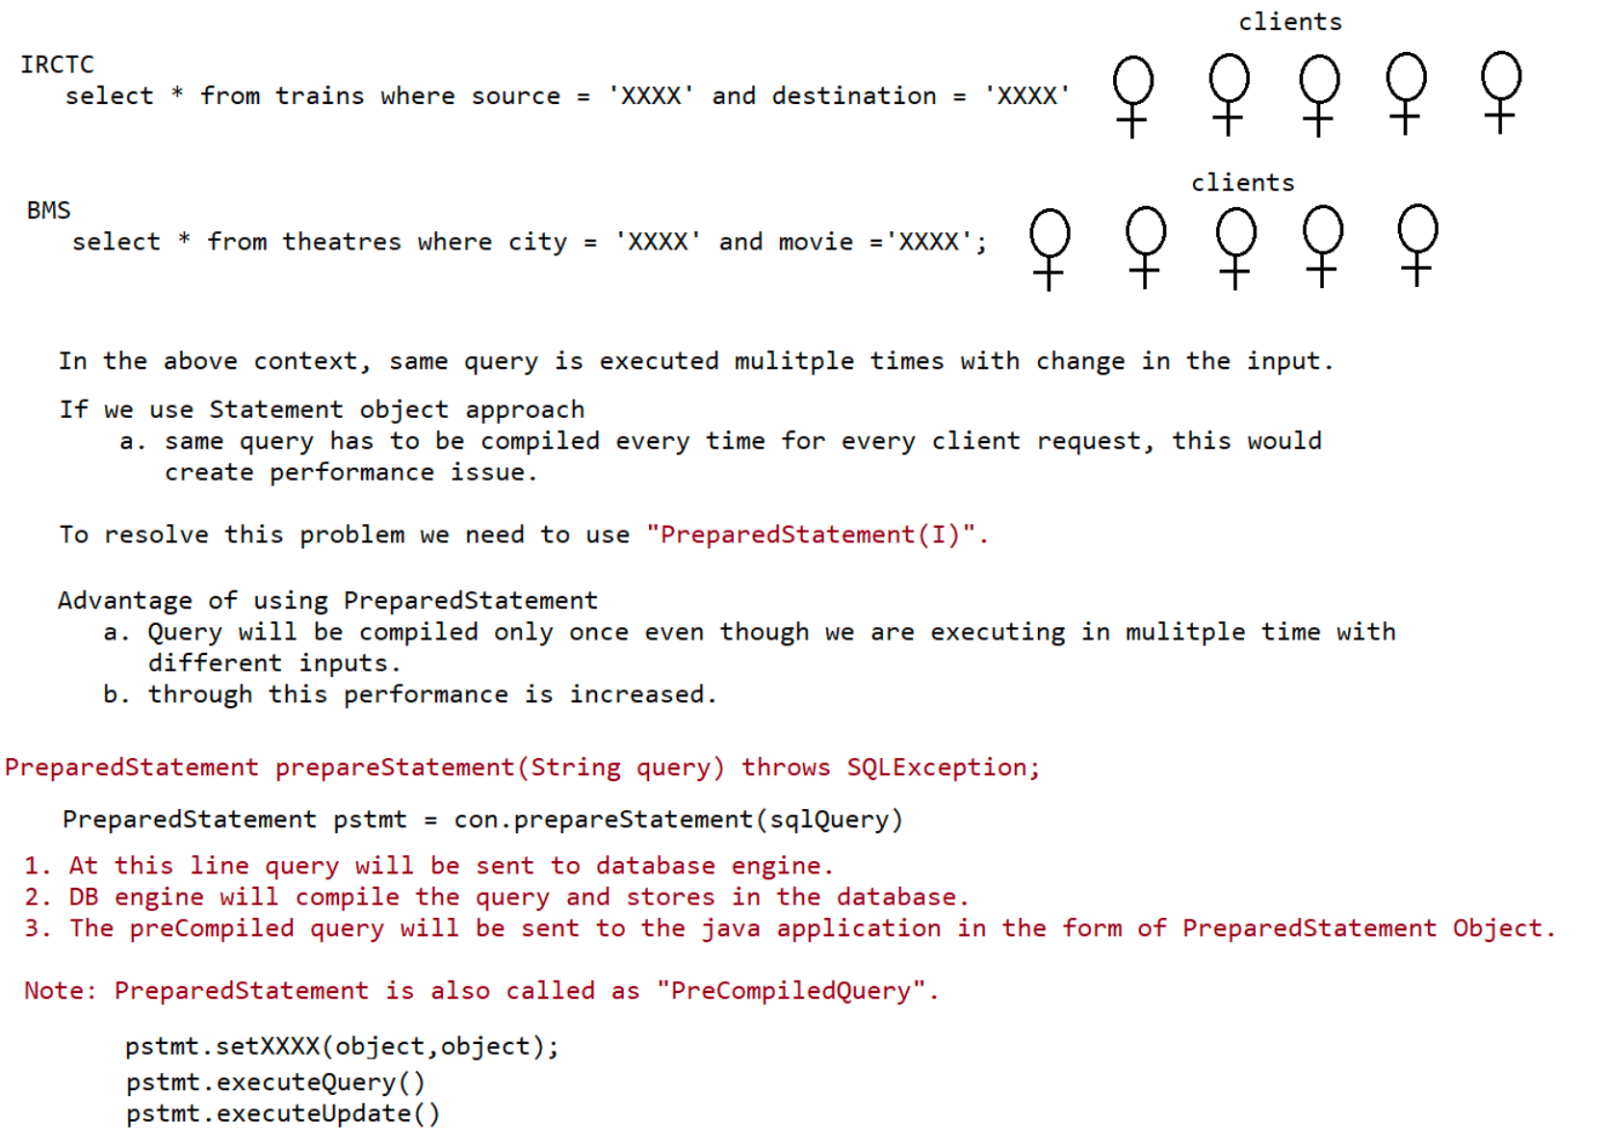
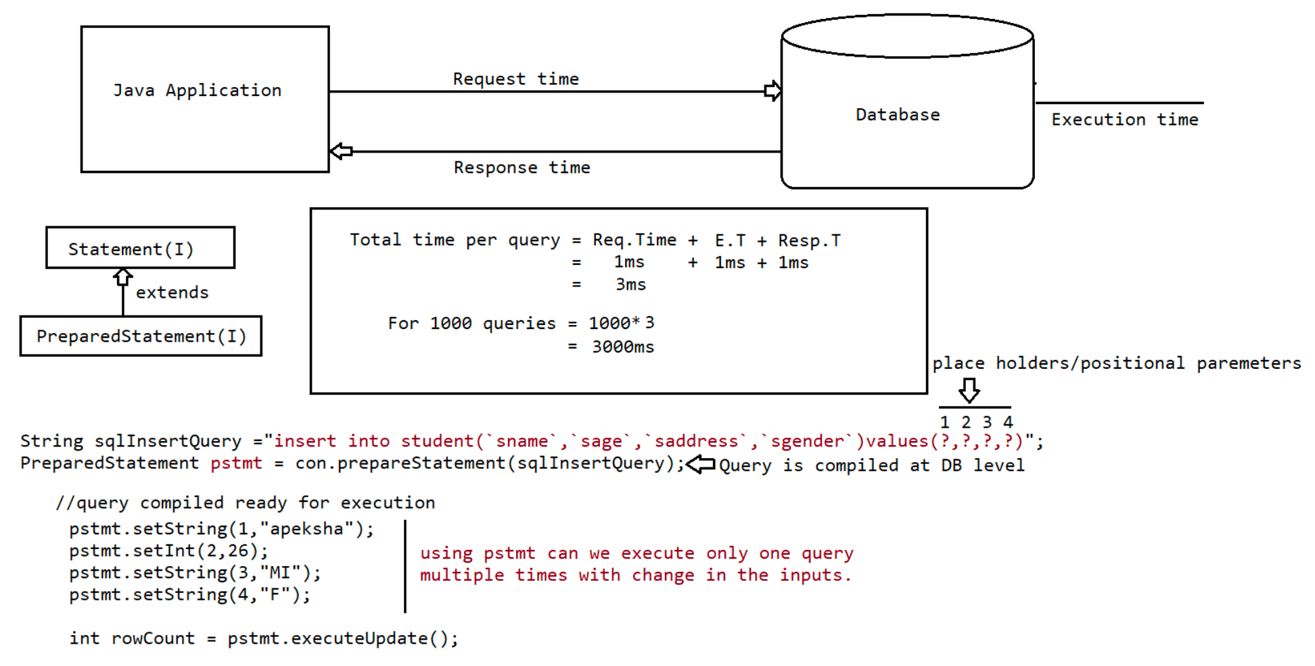

090 JDBC 4

Handling Date values for Database operations
======================================
=> Sometimes as the part of programing requirement,we have to insert and retrieve
Date like
DOB,DOJ,DOM,DOP...wrt database.
=> It is not recommended to maintain date values in the form of String,b'z
comparisons will become
difficult.
In Java we have two Date classes
1. java.util.Date
2. java.sql.Date
=> java.sql.Date is the child class of java.util.Date.
=> java.sql.Date is specially designed class for handling Date values wrt database.
Otherthan database operations,if we want to represent Date in our java program
then we should
go for java.util.Date.
=> java.util.Date can represent both Date and Time where as java.sql.Date
represents only Date but
not time.
1) class Test
2) {
3) public static void main(String[] args)
4) {
5) java.util.Date udate=new java.util.Date();
6) System.out.println("util Date:"+udate);
7) long l =udate.getTime();
8) java.sql.Date sdate= new java.sql.Date(l);
9) System.out.println("sql Date:"+sdate);
10) }
11) }
util Date:Mon Mar 20 19:07:29 IST 2017
sql Date:2017-03-20
Differences between java.util.Date and java.sql.Date
java.util.Date
1) It is general Utility Class to handle Dates in our Java Program.
2) It represents both Data and Time.
java.sql.Date
1) It is specially designed Class to handle Datesw.r.t DB Operations.
2) It represents only Date but not Time.
Note: In sql package Time class is availble to represent Time values and TimeStamp
class is
available to represent both Date and Time.
-> Inserting Date Values into Database:
Various databases follow various styles to represent Date.
Eg:
Oracle: dd-MMM-yy eg: 28-May-90
MySQL : yyyy-mm-dd eg: 1990-05-28
=> If we use simple Statement object to insert Date values then we should provide
Date value in the database supported format,which is difficult to theprogrammer.
=> If we use PreparedStatement,then we are not required to worry about database
supported form,
just we have to call
pst.setDate (2, java.sql.Date);
This method internally converts date value into the database supported format.
Hence it is highly recommended to use PreparedStatement to insert Date values into
database.
Steps to insert Date value into Database:
=> DB: create table users(name varchar2(10),dob date);
1. Read Date from the end user(in String form)
System.out.println("Enter DOP(dd-mm-yyyy):");
String dop=sc.next();
2. Convert date from String form to java.util.Date form by using SimpleDateFormat
object.
SDF sdf= new SDF("dd-MM-yyyy");
java.util.Date udate=sdf.parse(dop);
3. convert date from java.util.Date to java.sql.Date
long l = udate.getTime();
java.sql.Date sdate=new java.sql.Date(l);
4. set sdate to query
pst.setDate(2,sdate);
5. int rowAffected= pst.executeUpdate();//Execute the query.
***Note:
If end user provides Date in the form of "yyyy-MM-dd" then we can convert directly
that String into
java.sql.Date form as follows...
eg:: String s = "1980-05-27";
java.sql.Date sdate=java.sql.Date.valueOf(s);
Retrieving Date value from the database
========================================
=> For this we can use either simple Statement or PreparedStatement.
=> The retrieved Date values are Stored in ResultSet in the form of "java.sql.Date"
and we can get
this value by using getDate() method.
=> Once we got java.sql.Date object,we can format into our required form by using
SimpleDateFormat object.
Sequence
========
1. Database
(java.sql.Date)sqldate = rs.getDate(2);
2. Our required String Form
String s = sdf.format(sqldate);
3. String s holds the date.
Need of DTO in projects
====================
DTO -> It stands for Data Transfer Object.
This object is used for transferring the data from one layer to another layer in
realtime applications.

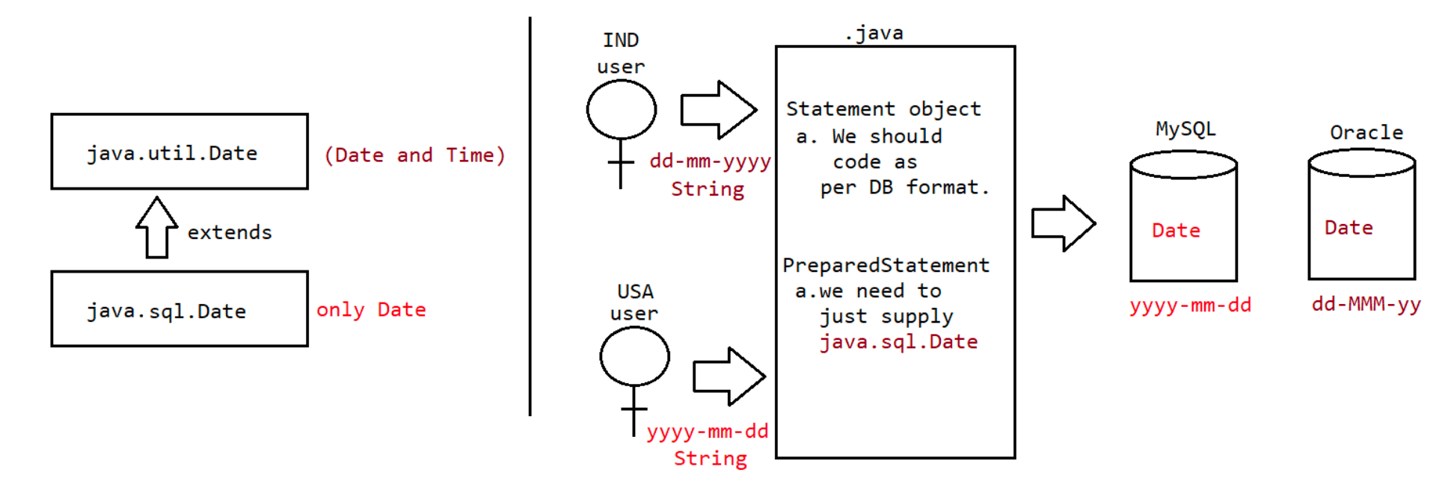
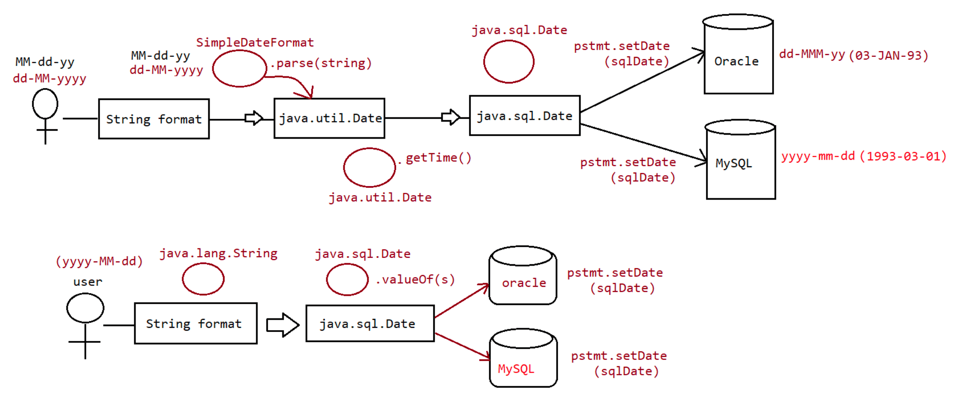
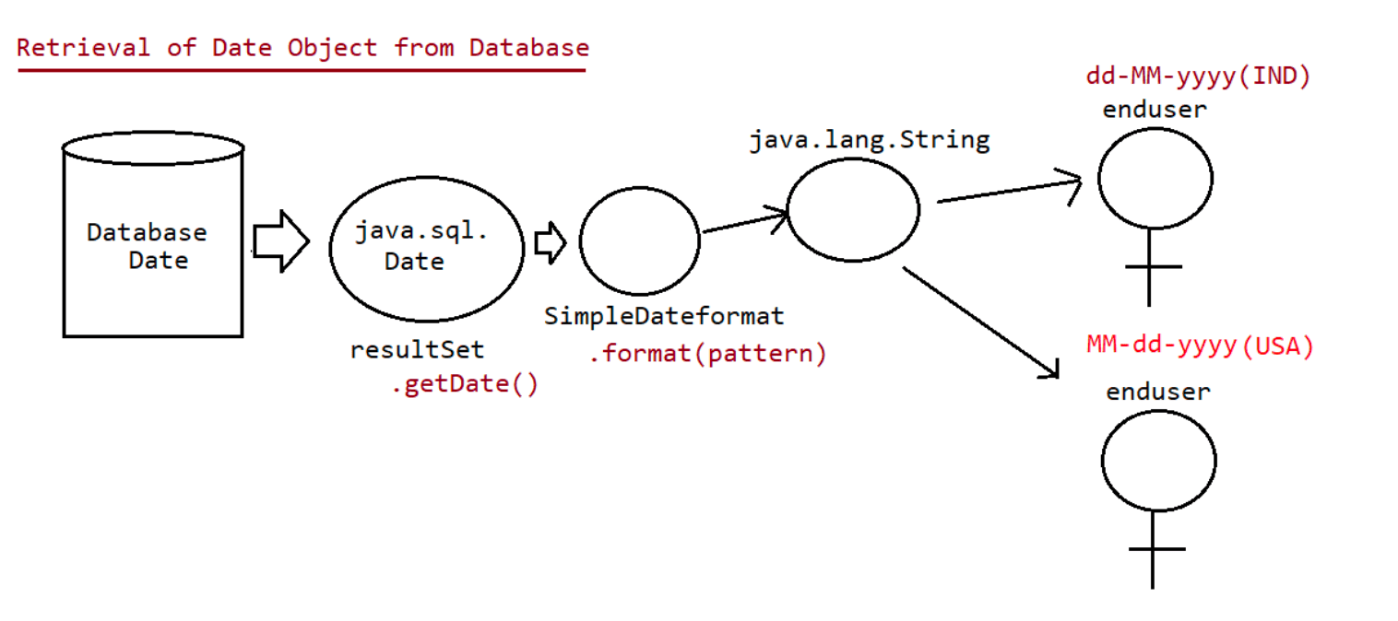
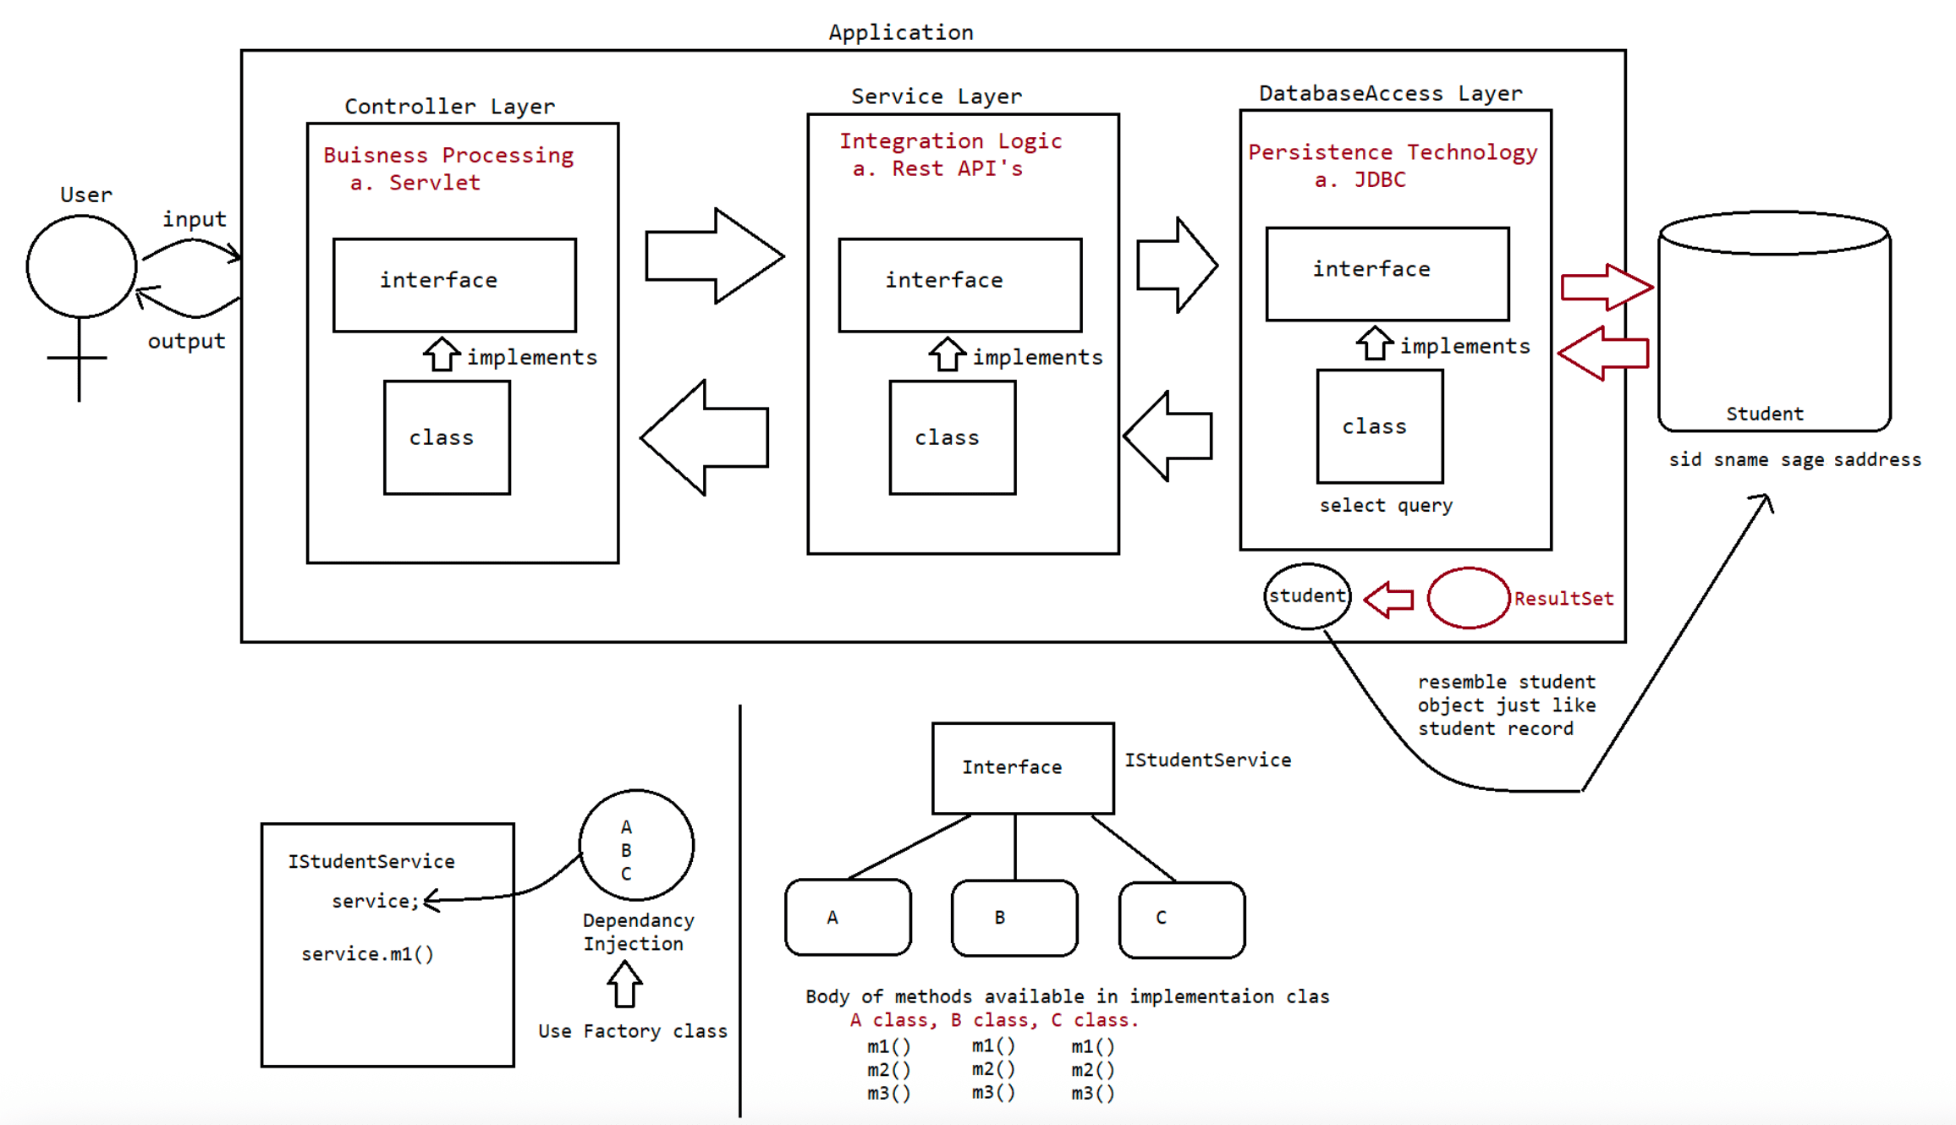

091 JDBC Advance 1

Working with Large Objects (BLOB And CLOB)
==========================================
Sometimes as the part of programming requirement,we have to insert and retrieve
large files like images,video files,
audio files,resume etc wrt database.
Eg:upload image in matrinomial web sites
upload resume in job related web sites
To store and retrieve large information we should go for Large Objects(LOBs).
There are 2 types of Large Objects.
1. Binary Large Object (BLOB)
2. Character Large Object (CLOB)
1) Binary Large Object (BLOB)
A BLOB is a collection of binary data stored as a single entity in the
database.
BLOB type objects can be images,video files,audio files etc..
BLOB datatype can store maximum of "4GB" binary data.
2) CLOB (Character Large Objects):
A CLOB is a collection of Character data stored as a single entity in the
database.
CLOB can be used to store large text documents(may plain text or xml documents)
CLOB Type can store maximum of 4GB data.
Eg: resume.txt
Steps to insert BLOB type into database:
1. create a table in the database which can accept BLOB type data.
create table persons(name varchar2(10),image BLOB);
2. Represent image file in the form of Java File object.
File f = new File("sachin.jpg");
3. Create FileInputStream to read binary data represented by image file
FileInputStream fis = new FileInputStream(f)
4. Create PreparedStatement with insert query.
PreparedStatement pst = con.prepareStatement("insert into persons
values(?,?)");
5. Set values to positional parameters.
pst.setString(1,"sachin");
To set values to BLOB datatype, we can use the following method: setBinaryStream()
public void setBinaryStream(int index,InputStream is)
public void setBinaryStream(int index,InputStream is,int length)
public void setBinaryStream(int index,InputStream is,long length)
6. execute sql query
pst.executeUpdate();
Steps to Retrieve BLOB type from Database
==========================================
1. Prepare ResultSet object with BLOB type
ResultSet rs = st.executeQuery("select * from persons");
2. Read Normal data from ResultSet
String name=rs.getString(1);
3. Get InputStream to read binary data from ResultSet
InputStream is = rs.getBinaryStream(2);4. Prepare target resource to hold BLOB data by using FileOutputStream
FileOutputStream fos = new FOS("katrina_new.jpg");
5. Read Binary Data from InputStream and write that Binary data to output Stream.
int i=is.read();
while(i!=-1)
{
fos.write(i);
is.read();
}
or
byte[] b= new byte[2048];
while(is.read(b) > 0){
fos.write(b);
}
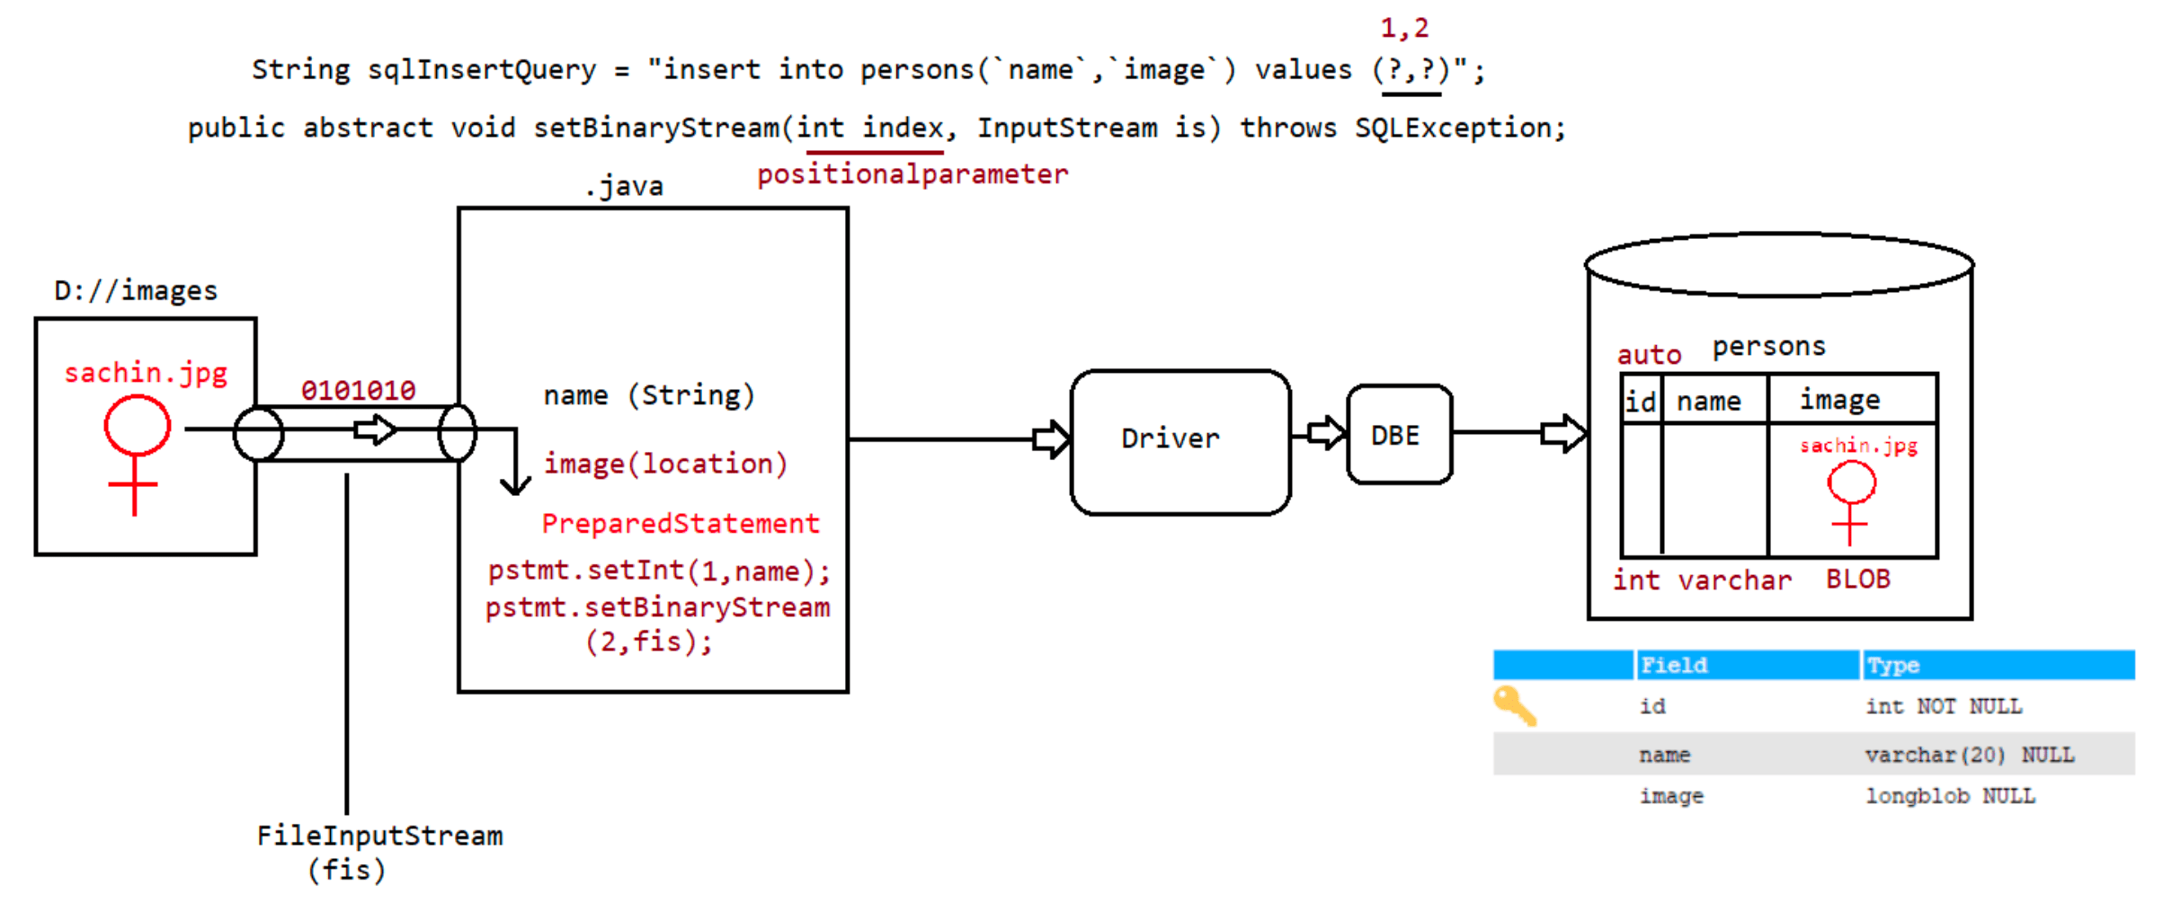
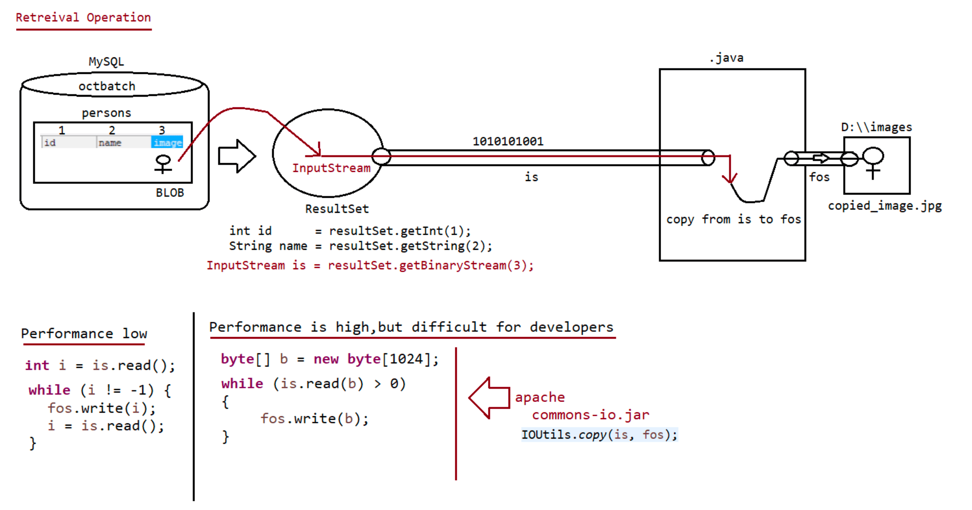
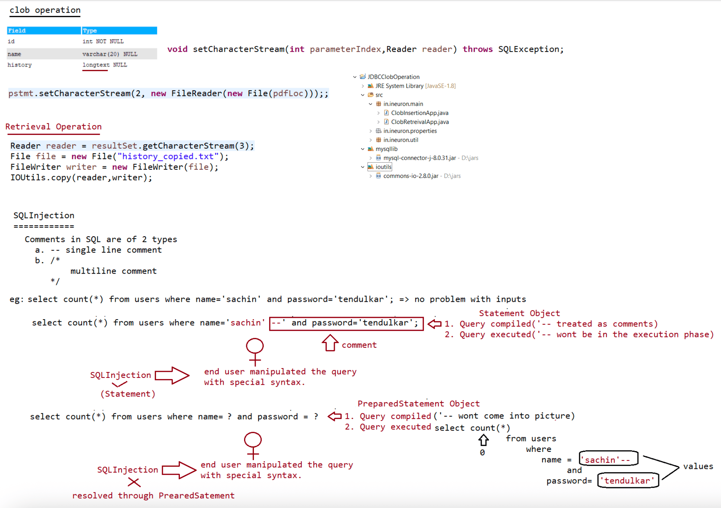
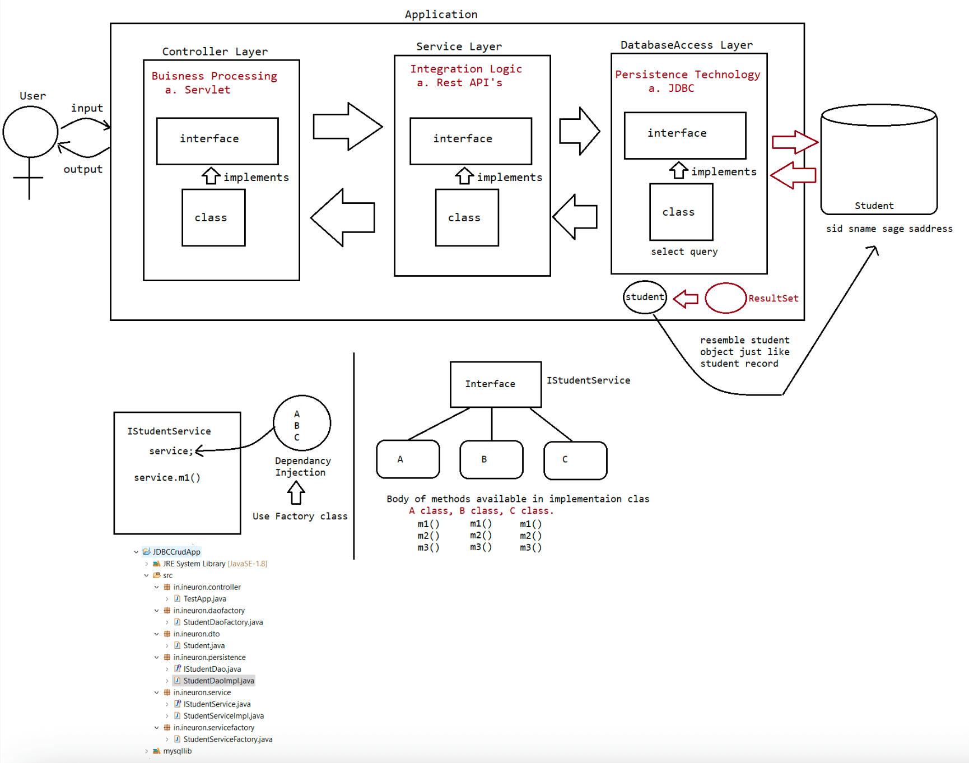

093 JDBC Advance 2

CallableStatement
===============
Statement(I) developer)
developer)
CallableStatement(I) present inside database)
=> Executing the query(Query should be written by java
PreparedStatement(I) => Executing the query(Query should be written by java
=> Executing the query(Query will be coded by DBA and
If we want to execute only StoredProcedure can we use Statement/PreparedStatement?
Answer: No, we need to use "CallableStatement"
In programming if any code is repeatedly required,we can define the code inside the
method and we can call that method
multiple times based on our requirement.
hence forth methods are best reusable component in programming.
Similarly in Database programming, if any group of sql statements is repeatedly
required then we define those sql statements
in a single group and we call that group repeatedly based on our requirement.
This group of sql statements that peform a particular task is nothing but
"Stored Procedure".
StoredProcedure is the best reusable component at database level.
StoredProcedure
It refers to group of sql statements that peform particular task.
These stored procedures are stored permanently in database for future usage and
hence the name "Stored procedure".
Usually StoredProcedures are created by DatabaseAdmin(DBA)
Every database has its own language to create StoredProcedures
a. Oracle -> PL/SQL
b. MySQL -> Stored Procedure Language
c. MicrosoftSQLServer -> Transact SQL(TSQL)
Similar to methods stored procedures has its own parameters.
Stored Procedures has 3 parameters
a. IN parameters(to provide input values)
b. OUT parameters(to provide output values)
c. INOUT parameters(to provide and to collect ouput)
Storedprocedure example
=====================
CREATE
PROCEDURE `octbatch`.`P_GET_PRODUCT_DETAILS_BY_ID`(
IN id INT,OUT NAME VARCHAR(20),OUT rate INT,OUT
qnt INT)
BEGIN
select pname,price,qty into name,rate,qnt from products where pid
= id;
END$$
DELIMITER ;
DBA will run the stored procedure as shown below
==========================================
To call the stored procedure we use the following syntax as shown below
CALL `P_GET_PRODUCT_DETAILS_BY_ID`(2,@name,@rate,@qty);
SELECT @name,@rate,@qty;Syntax for calling stored procedure from java program
=============================================
String storedProcedureCall="{CALL P_GET_PRODUCT_DETAILS_BY_ID(?,?,?,?)}";
CallableStatement cstmt = connection.prepareCall(storedProcedureCall);
When jvm encounters the above line, jvm will send the call to database.
DB engine will check whether the sepcified stored procedure is available or not.
if it is available then it will will return CallableStatement object representing
that procedure.
Note:
eg: CALL P_GET_PRODUCT_DETAILS_BY_ID(?,?,?,?)
setXXXX() -> availabe to take care of setting the input values as per the
DBengine datatypes.
eg: setInt(1,id)------------> int
setString(2,name)--> varchar
Before getting the value from the storedprocedure , we need to register the out
variables with java specific datatypes.
Registering the output variables of StoredProcedure
a. To map the Java datatype and Database specific datatypes we need to use
some mechanism.
b. The mechanism used is "JDBC Types" which is also known as "Bridge Types".
eg: java datatype -> int
JDBC type -> Types.INTEGER
DB datatype -> number
eg: java datatype -> String
JDBC type -> Types.VARCHAR
DB datatype -> varchar,varchar2
eg: java datatype -> java.util.Date
JDBC type -> Types.DATE
DB datatype -> Date
getXXXX() -> available to get the value from the DBE as per the DB specific
datatype
DB(varchar)------>JAVA(String)
Note
To execute stored procedure we use execute().
StoredProcedure to retrive all the records based on the product name
==========================================================
DELIMITER $$
CREATE
PROCEDURE `octbatch`.`P_GET_PRODUCT_BY_NAME`(IN name1 VARCHAR(20), IN name2
VARCHAR(20))
BEGIN
SELECT pid,pname,price,qty FROM products WHERE pname IN (name1,name2);
END$$
DELIMITER ;
To call storedprocedure we use the following syntax
CALL `P_GET_PRODUCT_BY_NAME`('fossil','tissot');output
pid pname price qty
1 fossil 15000 2
2 tissot 35000 3
refer: JDBCCallableStatementApp
BatchUpdate
===========
refer: JDBCBatchUpdate

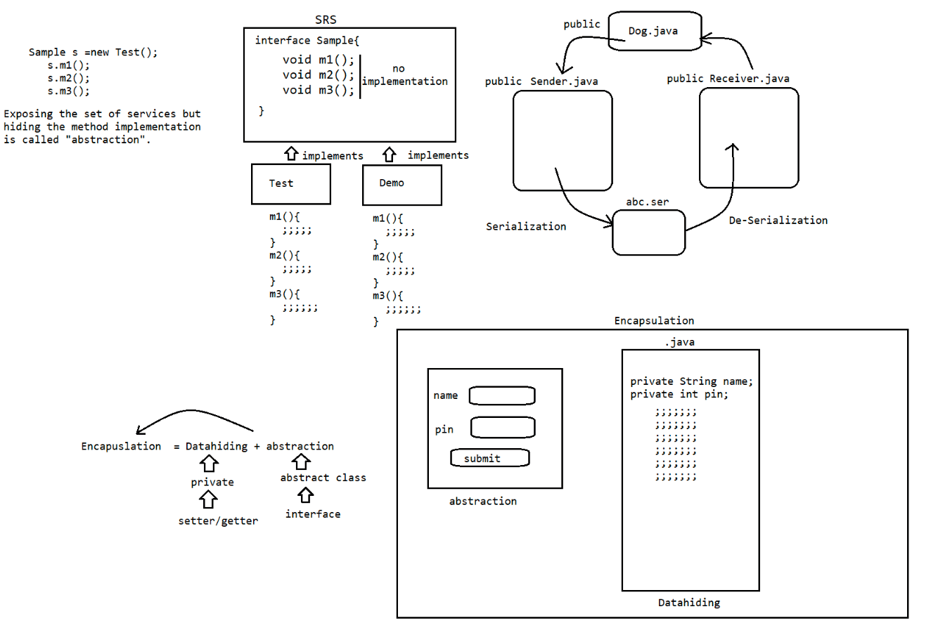
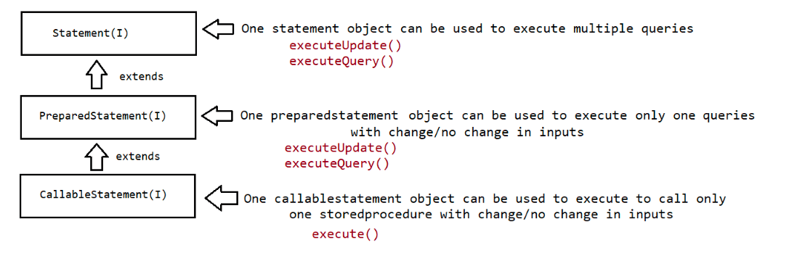
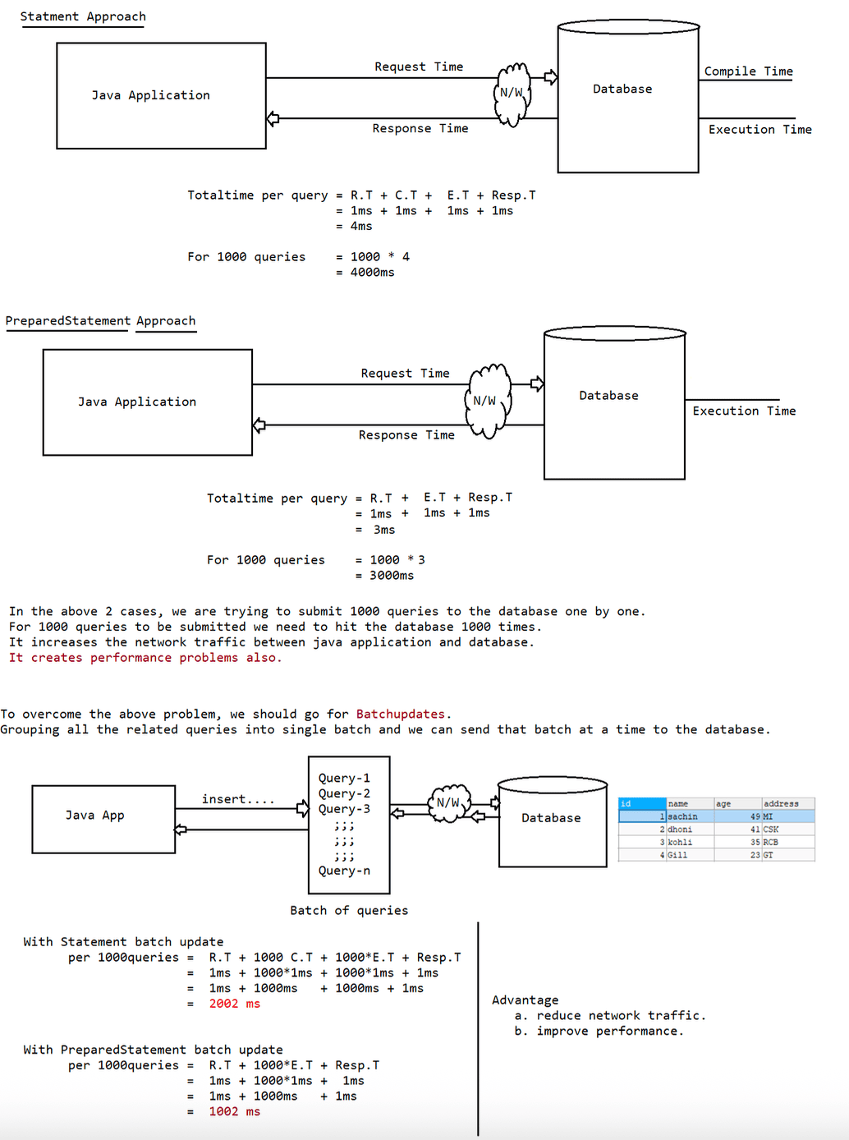
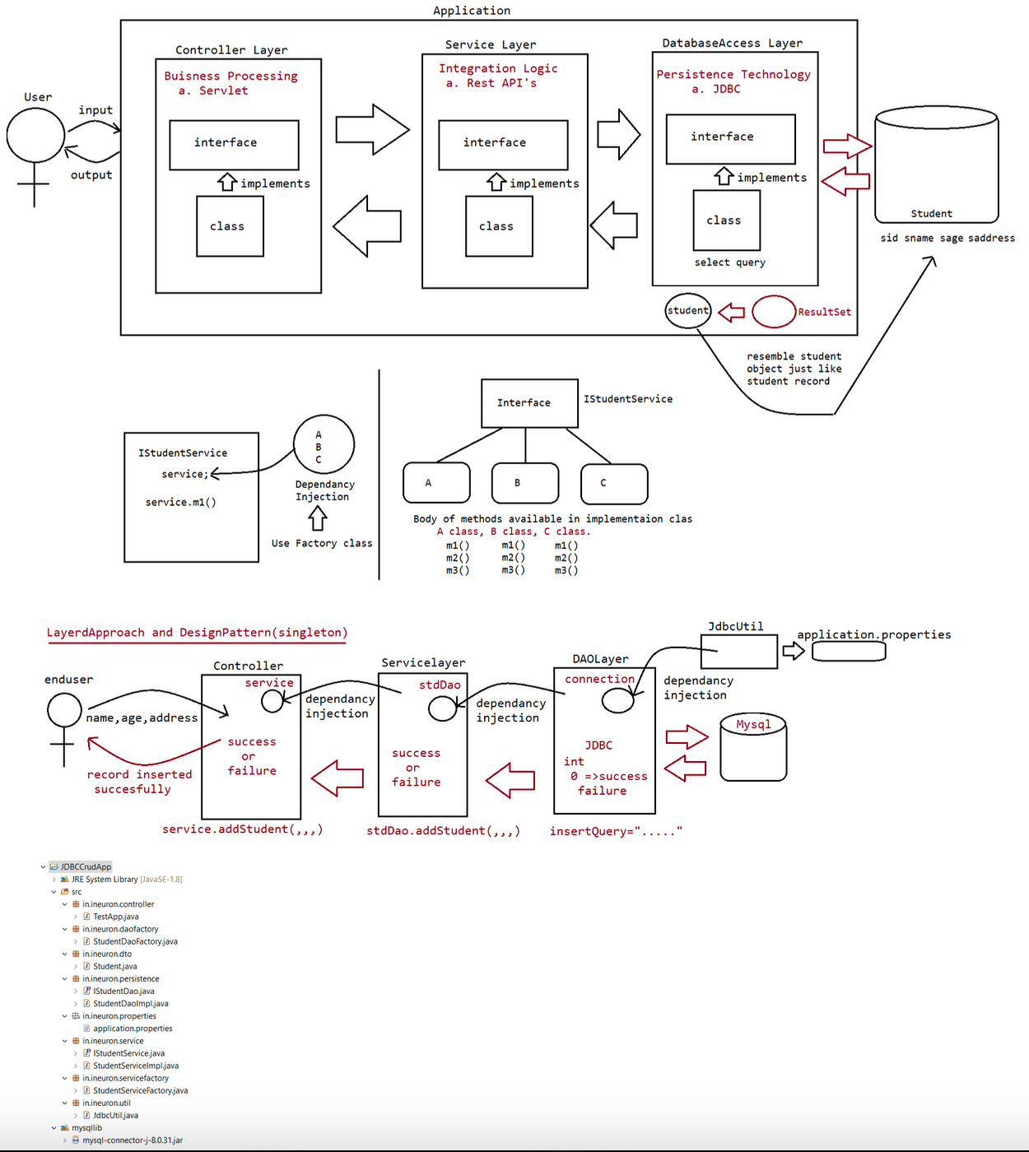

094 JDBC Advance 3

TransactionManagement
=====================
Process of combining all the related operations into a single unit and executing on
the rule "either all or none" is referred as
"Transaction Management".
Case1 : Fund trasfer
1. debit funds from sender account (update query with bal=bal-amt)
2. credit funds into reciever account(update query with bal=bal+amt)
All operations should be peformed as single unit.
if money from sender account is debited, and if the money doesn't reach to
receiver's account then there may be a
chance of "Data inconsistency problem".
Case2: Movie Ticket Reservation
1. verify the status
2. Reserve the ticket
3. Payment
4. Issue ticket
All operations should be peformed as single unit.
If some operations success and some operations fails then there may be "Data
inconsistency problem".
Transaction Properties
==================
Every Transaction should follow the following four ACID properties
a. A -> Atomicity
Either all operations should be done or none.
b. C -> Consistency
It should ensure bringing the database from one state to another state.
c. I -> Isolation
It ensures the transactions are isolated from other transactions.
d. D -> Durability
It means once the transaction is commited,the results are permanent
even in the case of system restart, errors,etc..
What are the types of Transactions available?
a. Local Transaction
b. Global Transaction
a. Local Transaction
All operations in transaction are executed over the same database.
eg: Funds transfer from one account to another account where the
both the accounts in the same bank.
b. Global Transaction
All operations in transaction are executed over the different database.
eg: Funds transfer from one account to another account where the
accounts are related to different banks.
Note:
JDBC supports only local transactions.
If we want global transactions then we need to go for frameworks like
Spring/hibernate or EJB's.
Process of transaction management in JDBC====================================
1. Disable the autocommit nature of JDBC
connection.setAutoCommit(false);
2. If all operations are completed means then we can commit the transaction using
the following method
connection.commit();
3. if any sql query fails, then we need to rollback the operations which are
already completed using the following method
connection.rollback();
SavePoint(I)
=========
Within a transaction, if we want to rollback a particular group of operations
based on some condition then we need to use
savepoint
a. getting savepoint using the following method
Savepoint sp = connection.setSavePoint();
b. To perform rollback operation for a particular group of operations w.r.t
savepoint then we need to use rollback .
connection.rollback(sp);
c. we can release the savepoint or delete the savepoint as shown below
connection.releaseSavePoint(sp);
Case study
=========
connection.setAutocommit(false);
operation-1
operation-2
operation-3
SavePoint sp = connection.setSavePoint();
operation-4
operation-5
if(balance<1000)
connection.rollback(sp);
else
connection.releaseSavepoint(sp);
connection.commit();
if balance< 1000 then operation 4,5 will be rollbacked,otherwise all the operations
will be commited.
eg:
connection.setAutocommit(false);
st.executeUpdate("insert into politicians values('BJP','Modi'));
st.executeUpdate("insert into politicians values('TRS','KCR')");
SavePoint sp = connection.setSavePoint();
st.executeUpdate("insert into policitions values('BJP','siddu')");
connection.rollback(sp);
;;;;
;;;
connection.releaseSavePoint(sp);
;;;
;;;
connection.commit();Types of ResultSet
==============
refer: ****.png
absolute() -> it works from the BFR or from ALR.
relative() -> it works w.r.t current position.
In both the methods positive means move in forward direction, negative means move
in backward direction.
Note:
rs.last() and rs.absolute(-1) both are equal
rs.first() and rs.absolute(1) both are equal

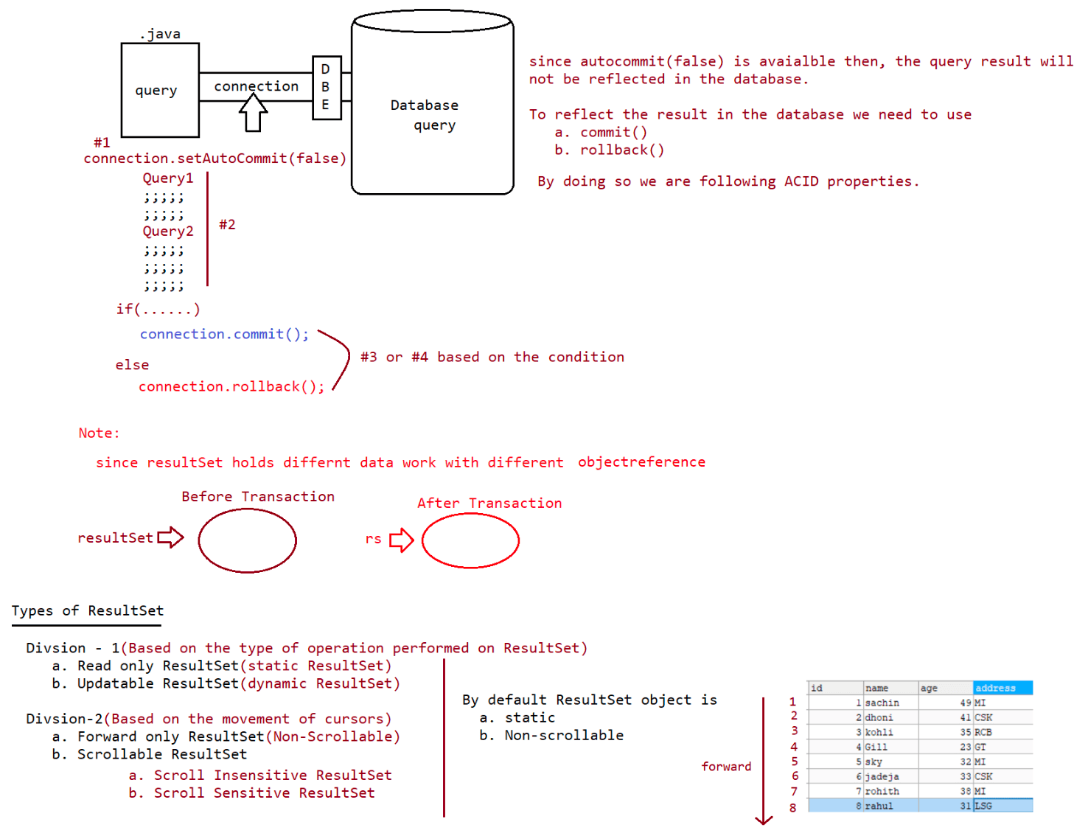
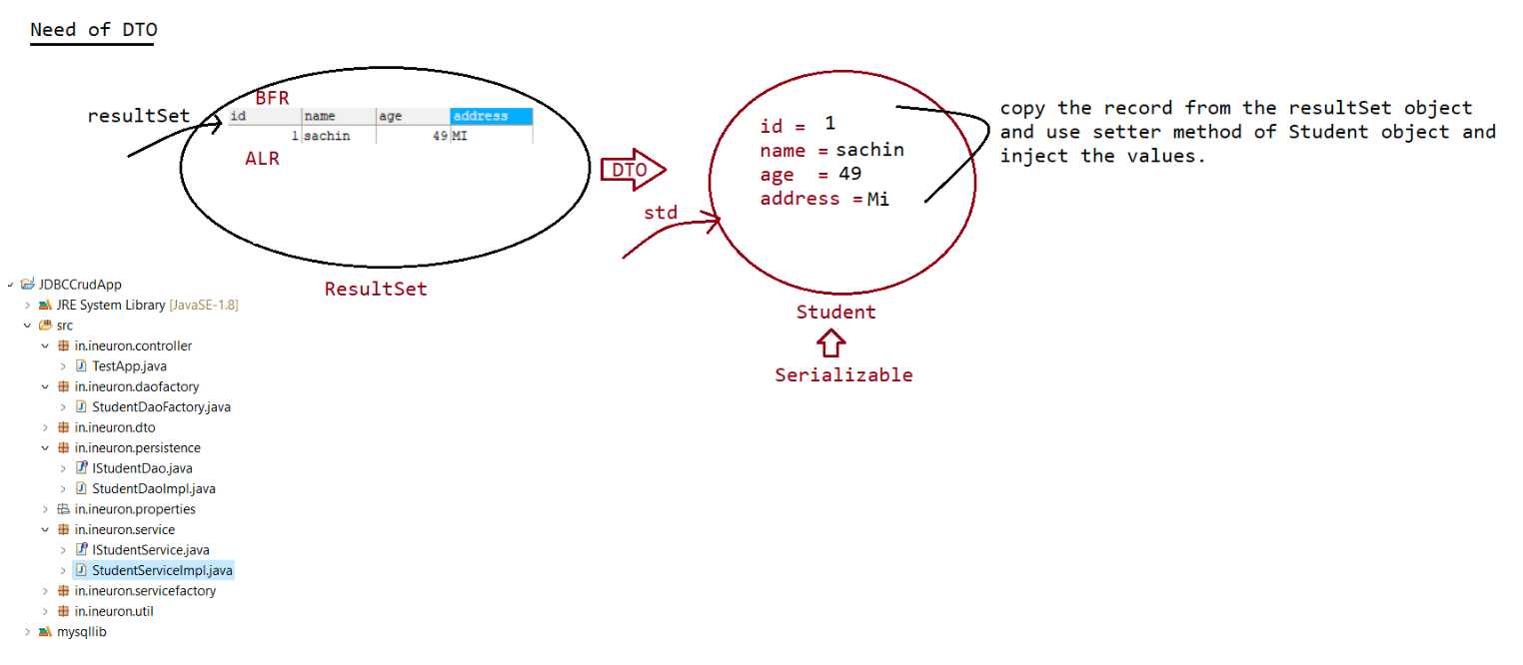

095 JDBC Advance 4

ResultSet types
============
Division-1
a.Read only ResultSet(static resultset)
b. updatable ResultSet(dynamic resultset)
Division-2
a. NonScrollable ResultSet(forward only)
b. Scrollable ResultSet
1 In-Sensitive ResultSet
2. Sensitive ResultSet
Scroll InSensitive ResultSet
After getting resultSet if we are performing any operations in the database,
and if those changes are not reflecting to
the resultSet, such type of ResultSet are called as "Scroll Insensitive
ResutlSet".
public static final int TYPE_SCROLL_INSENSITIVE
Scroll Sensitive ResultSet
After getting resultSet if we are performing any operations in the database,
and if those changes are getting reflecting to
the resultSet, such type of ResultSet are called as "Scroll Sensitive
ResutlSet".
public static final int TYPE_SCROLL_SENSITIVE
Note:
When we make the ResultSet as ScrollSensitive, then we need to use
resultSet.refreshRow() to get the updated records
from the database.
Updatable ResultSet
=================
query
It is possible to perform delete operation using resultSet without writing delete
resultSet.deleteRow() -> This method would delete the record based on the
cursor position of ResultSet.
It is possible to perform insert operation using resultSet without writing insert
query
a. resultSet.moveToInsertRow()//creates a empty record.
b. resultSet.updateXXXX(int pos,Object value);// insert the value based on
the column data.
c. resultSet.insertRow();// record will be inserted to the table with the
updated values.
It is possible to peform update operation using resultSet without writing update
query
a. resultSet.getXXXX(int pos) // getting the old value from resultSet
b. resultSet.updateXXXX(int pos, Object newValue); // update the newValue
w.r.t resultSet
c. resultSet.updateRow();// record will be updated to the table as per the
resultSet information.
Working with Excel sheet
---------------------------------
To work with Excel sheet, we need to use HXTT company supplied driver we need to
use.eg: EXCEL_JDBC40.jar
Working with CSV files
------------------------------
To work with CSV files, we need to use HXTT company supplied driver we need to use.
eg: Text_JDBC42.jar

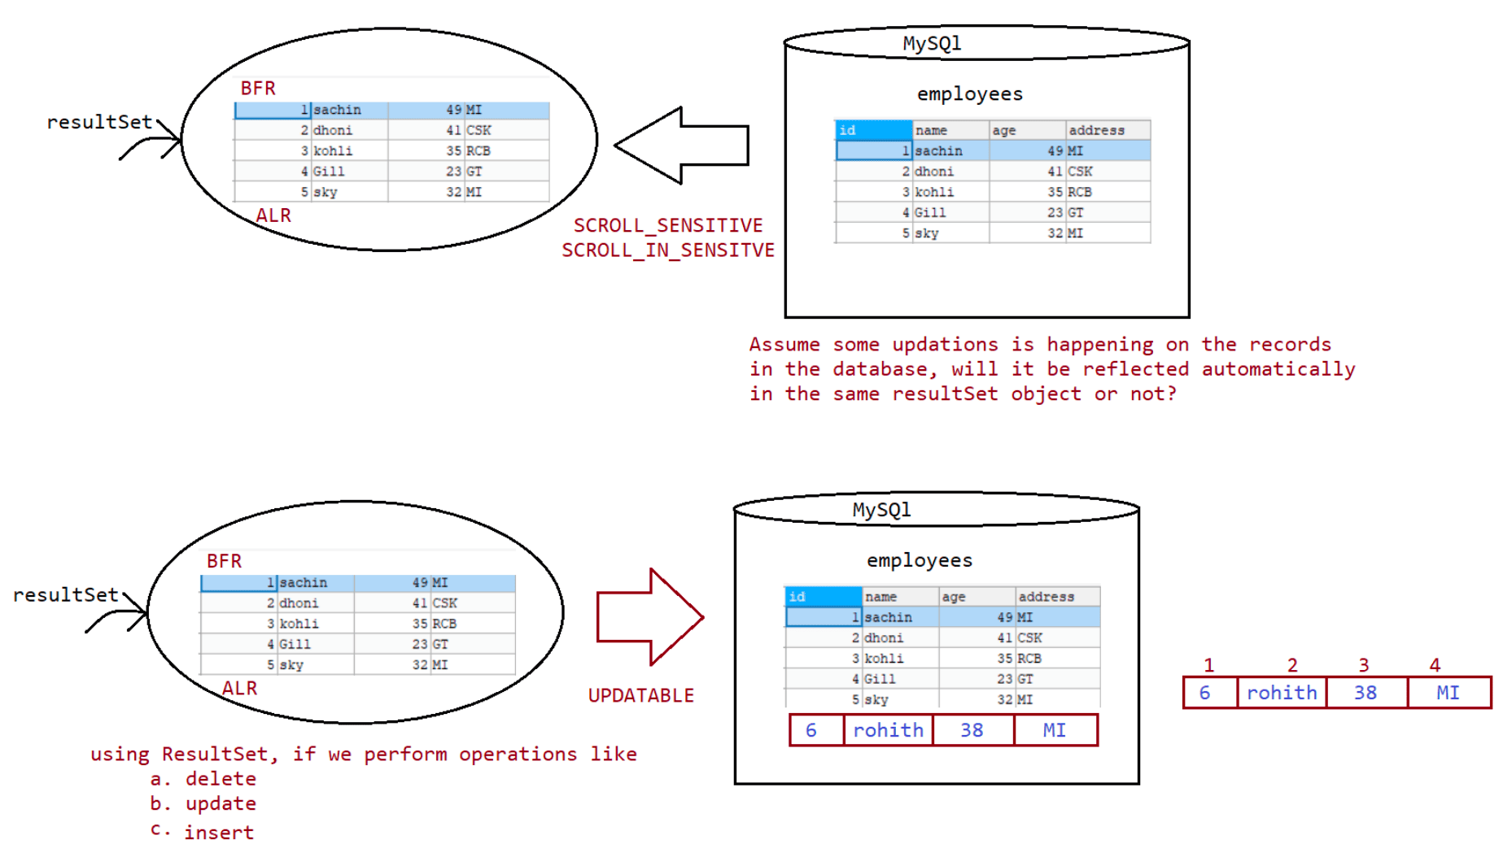
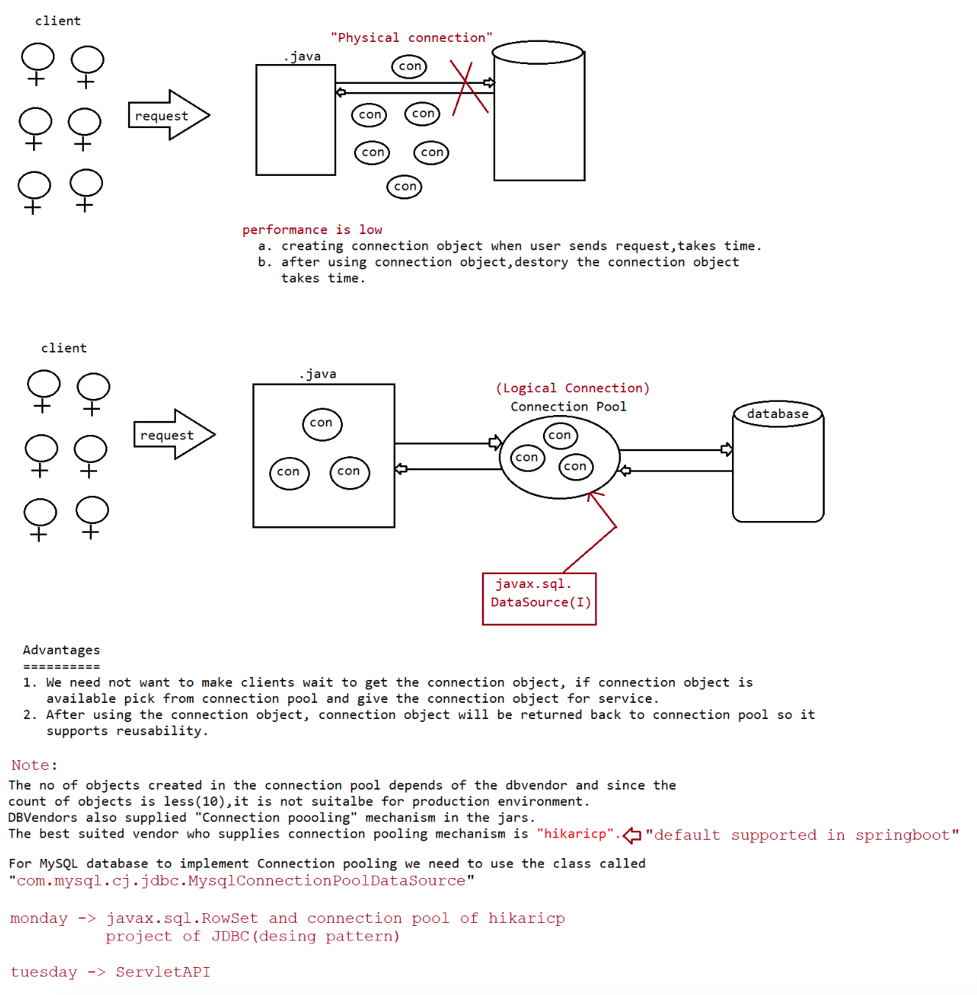

097 JDBC Advance 5

HikariCp
=======
HikariCP is a "zero-overhead" production ready JDBC connection pool.
It is the 3rd party supplied jar which helps us to imporve connection pooling
apporach.
To use hikaricp in our applications we need to use 2 jars
a. hikaricp jar
b. sl4j jar
import java.sql.Connection;
import java.sql.ResultSet;
import java.sql.Statement;
import com.zaxxer.hikari.HikariConfig;
import com.zaxxer.hikari.HikariDataSource;
public class TestApp {
public static void main(String[] args) throws Exception {
String configFile = "src\\in\\ineuron\\main\\db.properties";
HikariConfig config = new HikariConfig(configFile);
try (HikariDataSource dataSource = new HikariDataSource(config)) {
// Getting the connection object from conenction pool
Connection connection = dataSource.getConnection();
Statement statement = connection.createStatement();
ResultSet resultSet = statement.executeQuery("select
id,name,age,address from employees");
System.out.println("ID\tNAME\tAGE\tADDRESS");
while (resultSet.next()) {
System.out.println(resultSet.getInt(1) + "\t" +
resultSet.getString(2) + "\t" + resultSet.getInt(3)
+ "\t" + resultSet.getString(4));
}
}
}
}
db.properties
===========
jdbcUrl=jdbc:mysql:///octbatch
dataSource.user=root
dataSource.password=root123
output
ID NAME AGE ADDRESS
1 sachin 50 MI
2 dhoni 41 CSK
3 kohli 33 RCB
4 Gill 23 GT
7 rohith 38 MI
Note: Since hikaricp datasource is best for connection pooling, In
Spring,SpringBoot by default hikaricp connection pooling
is available.
javax.sql.RowSet==============
It is an alternative to ResultSet.
We can use RowSet to handle group of recordds in more effective way than
ResultSet.
RowSet is a child interface of ResultSet.
By default RowSet is scrollable and updatable.
By default RowSet object implements Serializable, so RowSet object can be sent
over the network.
ResultSet object is by default Connected object, where as if use RowSet we can
work in both the modes like
Connected/DisConnected mode.
There are 2 types of RowSet
a. Connected RowSet.
b. DisConnected RowSet.
Creation of different row set objects
==============================
package in.ineuron.main;
import javax.sql.rowset.CachedRowSet;
import javax.sql.rowset.FilteredRowSet;
import javax.sql.rowset.JdbcRowSet;
import javax.sql.rowset.JoinRowSet;
import javax.sql.rowset.RowSetFactory;
import javax.sql.rowset.RowSetProvider;
import javax.sql.rowset.WebRowSet;
public class TestApp {
public static void main(String[] args) throws Exception {
RowSetFactory rsf = RowSetProvider.newFactory();
JdbcRowSet jrs = rsf.createJdbcRowSet();
CachedRowSet crs = rsf.createCachedRowSet();
WebRowSet wrs = rsf.createWebRowSet();
JoinRowSet jnrs = rsf.createJoinRowSet();
FilteredRowSet frs = rsf.createFilteredRowSet();
System.out.println(jrs.getClass().getName());
System.out.println(crs.getClass().getName());
System.out.println(wrs.getClass().getName());
System.out.println(jnrs.getClass().getName());
System.out.println(frs.getClass().getName());
}
}
Output
com.sun.rowset.JdbcRowSetImpl
com.sun.rowset.CachedRowSetImpl
com.sun.rowset.WebRowSetImpl
com.sun.rowset.JoinRowSetImpl
com.sun.rowset.FilteredRowSetImpl
Note: Implementation for RowSet is provided by java vendor only, not by db vendors.

